Year 8
V is for Vegetable

Name: ………………………………………….
Form Group: ………………
Technology Group: ……………………………
Food Technology Teacher: ………………………………………….

Medal task:

Gold: understands a range of types of food and ways to cook and store them

Silver: knows how to stay safe in the kitchen and keep others safe, can identify a number of dangers in the kitchen environment

Bronze: Has a good understanding of food hygiene, storing food and ways to reduce food poisoning

Power of 3

Name 3 types of vegetable

What does carbohydrate do for the body?

What is cross contamination?

Explain 3 things you learnt from food in year 7?
Safety in the Kitchen
Learning Objectives
By the end of this task you should be able to:
- list safety rules for working in the Food Technology room;
- know how to use the fire blankets in the Food Technology room.

Keywords: risk, safety, hazards, dangerous, prevention.

The Food Technology classroom is one of the most dangerous rooms in the school. There are 20 students using hobs, ovens, electrical appliances, hot water and knives. Therefore, everyone must agree on some simple safety rules to prevent accidents.

Below are a few safety rules. See if you can spot any potential hazards in the classroom and write safety rules to share with the class.

Safety Rules

- Do not run.

- Work quietly at all times.

- Listen carefully to all instructions given to you.

- Always push stools under the tables.

- _____________________________________________
- _____________________________________________
7. _____________________________________________
8. _____________________________________________
9. _____________________________________________
10. _____________________________________________


Fire Safety
It is very unlikely that a fire will start in the classroom. However it is important to make sure everyone knows what to if there is one.

- Where are the fire blankets located?

- What do you use the fire blankets for? How do you use the fire blankets?

- What should you do if there is a fire? Who should you tell? Where should you go?

Power of three

What is cooking temperature?

Explain two safety rules in the kitchen

Name 2 English dishes?

Level up

Medal task

Gold: Has shown a good understanding of hygiene and safety in the kitchen

Silver: Completed fire safety to a good standard

Bronze: understands how to stay safe in the kitchen
Equipment

Why would you use each of the following pieces of equipment?

  Sieve  ………………………………………………………….  …………………………………………………………. | 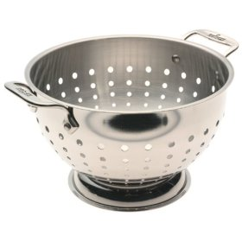  Colander  ………………………………………………………….  ………………………………………………………….
Blender  ………………………………………………………….  …………………………………………………………. | 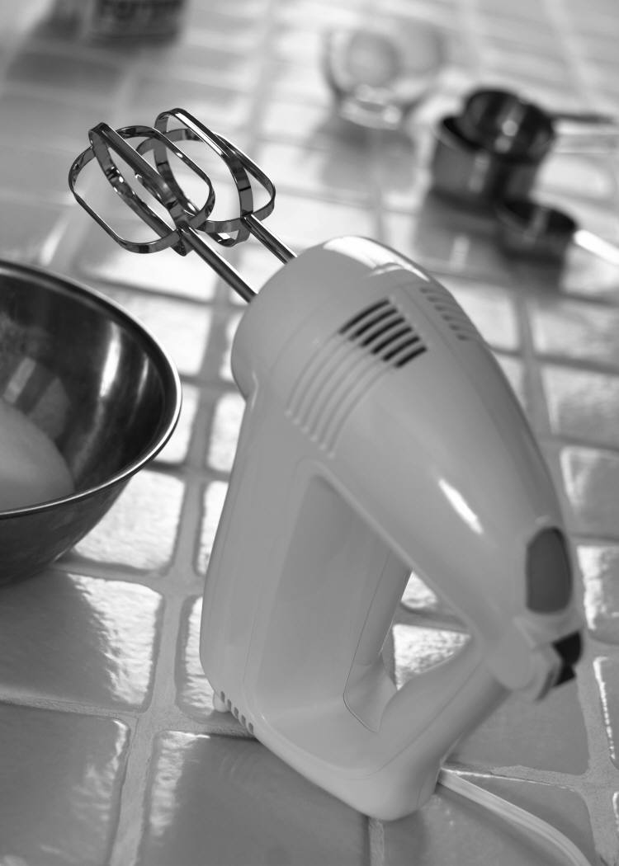  Electric whisk  ………………………………………………………….  ………………………………………………………….
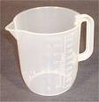  Measuring jug  …………………………………………………………. | 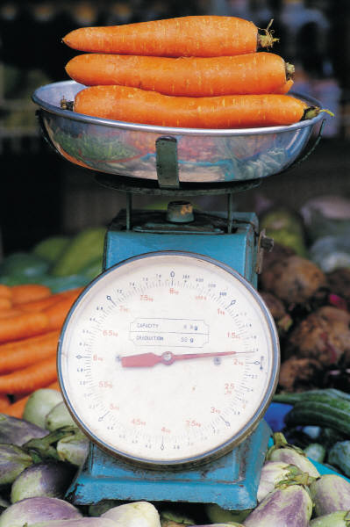  Scales  ………………………………………………………….

Correct the spelling errors in Food Technology

Incorrect spelling | Correct spelling | Incorrect spelling | Correct spelling
Vegatables |  | choclate
Ingrediants |  | bactiria
Potatoe |  | food poosening
Potatos |  | contamenation
Tomatoe |  | wisk
Tomatos |  | Creeming method
Self-rasing flower |  | Need the doe
Cauliflour
Brocoli
Mesure
Simer

Practical 1: Leek and Potato Soup

Learning Objectives
By the end of this task you should be able to:
- prepare an onion (bridge hold and claw grip);
- measure liquids accurately using a measuring jug;
- use the hob safely;
- sweat the onion, simmer the soup;
- sweat onions using a cartouche;
- use the blender, hand blender or food processor safely;
- make a soup, e.g. Leek and Potato Soup or Thai Butternut Squash Soup.

Questions
Use cookbooks to find soup recipes and complete questions 1 to 3.

1) Which ingredients are found in all recipes? ……………………………………………………………………………
2) Approximately how long does it take for soup to cook? ………………………………………………………………
3) Give an example of a finishing technique you might use on your soup? …………………………………………
4) Write two important safety rules for using the blender when you make your soup.
..………………………………………………………………………………………………………………………..
………………………………………………………………………………………………………………………..

Brainstorm
Write on the chart below lots of ideas/ingredients that you could use for your soup.

Ingredients to use in your vegetable soup

Leek and Potato Soup
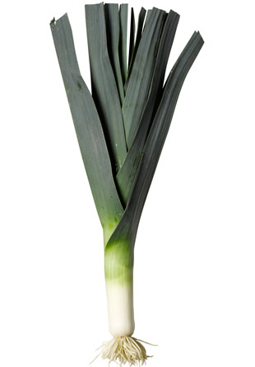
Ingredients
1 onion
1 leek
1 potato
400ml stock
salt and pepper to season

To garnish (finishing technique)
Snipped chives or chopped parsley

Method
- Dice the onion. Sweat the onion for 10 minutes
- Trim the leek and discard the tough outer layer. Cut the leek in half lengthways and slice it. Then wash it thoroughly. Drain well.
- Add the leeks to the saucepan. Then add the potatoes. Stir with a wooden spoon.
- Season with salt and pepper.
- Add the stock, bring to the boil then simmer for 20 minutes or until the vegetables are soft.
- Put the soup into a blender – leave it to cool a little first – and blend to a purée.
- Return the soup to the saucepan and reheat gently, tasting to check the seasoning.
Reading a Food Label
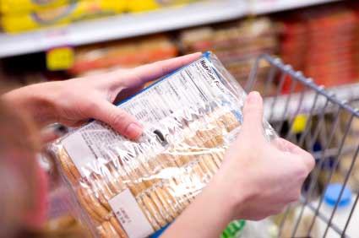
Learning Objectives
By the end of this task, you should be able to:
- know the legal requirements for food labelling;
- make decision about food based on the label.

Keywords: label, analysis.

It is a legal requirement to inform customers about the food products they are buying. The Food Labelling Regulations 1996 states the information that must be displayed.

Legally the following information must be displayed
- Name of the food (people should know what the product is.)
- List of ingredients
- Food allergies
- Nutritional information
- Date Marking. There are two types:
- Use by Day and Month or Day, Month Year for perishable foods
- Best Before - date until which the food will maintain its optimum quality, e.g. foods that become stale or develop off-flavours, such as biscuits, crisps, or soft drinks.
- Storage conditions
- Instructions for use
- Business name and address
- Place of origin

Traffic Light Labelling
You're standing in a supermarket aisle looking at two similar products, trying to decide which to choose. You want to make the healthier choice but, you're in a hurry. Well, help is at hand. A growing number of supermarkets and food manufacturers are using traffic light colours on the labels of some products.
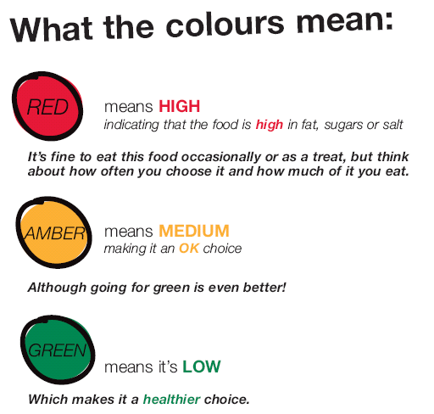
Traffic Light Labelling
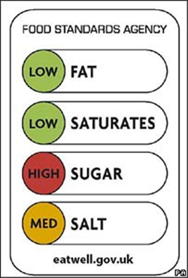
Activity
Use coloured pencils and the information from the PowerPoint to decide whether each nutrient below should be green, orange or red. Which of these breakfast cereals is the healthiest? The nutrition tables below are all per 100g.

Cornflakes £2.26 for 750g
kJ | 1580
Protein | 7g
Carbohydrate  - sugar  - starch | 84g  8g  76g
Fat  Saturates | 0.9g  0.2g
Fibre | 3g
Sodium | 0.7g

Frosties £2.38 for 750g
kJ | 1587
Protein | 4.5g
Carbohydrate  - sugar  - starch | 87g  37g  50g
Fat  Saturates | 0.6g  0.1g
Fibre | 2g
Sodium | 0.45g

Bran Flakes £1.76 for 500g
kJ | 1503
Protein | 10g
Carbohydrate  - sugar  - starch | 67g  22g  45g
Fat  Saturates | 2g  0.5g
Fibre | 15g
Sodium | 0.4g

Nutri-Grain raspberry bake bar£2.26 for 8bars
kJ | 1720
Protein | 4.5g
Carbohydrate  - sugar  - starch | 64g  33g  31g
Fat  Saturates | 15g  2g
Fibre | 2.5g
Sodium | 0.1g

Questions
1) Explain the importance of eating breakfast each day? (Use the word ‘energy’ in your answer.)

2) Which of the above breakfast cereals is the healthiest and why?

3) Suggest three ideas for improving the nutritional value of the healthiest breakfast cereal?

Level up:

Tips for Eating Well | Why is this important?

Extension: Why did the government spend so much money on writing the 8 Tips for Eating Well?

Medal task:

Gold: Has shown an outstanding understanding of nutrition and ways to eat healthy

Silver: Understands how to identify good healthy foods from food labelling

Bronze: Has shown an understanding of the eatwell guide
Practical 2: Omlette

WHAT YOU NEED

2 EGGS
Dash of salt
Dash of pepper
1 tsp. butter
1/3 to 1/2 cup filling, such as shredded cheese, finely chopped ham, baby spinach
DIRECTIONS

BEAT eggs, water, salt and pepper in small bowl until blended.

HEAT butter in a Frying pan over medium-high heat until hot. TILT pan to coat bottom. POUR IN egg mixture. Mixture should set immediately at edges.

GENTLY PUSH cooked portions from edges toward the centre with inverted turner so that uncooked eggs can reach the hot pan surface. CONTINUE cooking, tilting pan and gently moving cooked portions as needed.

When top surface of eggs is thickened and no visible liquid egg remains, PLACE filling on one side of the omelette. FOLD omelette in half with turner. With a quick flip of the wrist, turn pan and INVERT or SLIDE omelette onto plate. SERVE immediately.

Skills
Using the hob | Onion preparation (Bridge hold / Claw grip) | Simmering (heat control)

Question
What other dishes could this sauce be used in?

Power of 3

Why is the eatwell guide good for young people?

What nutrient does milk have in it and what does it do for the body?

What nutrient do eggs have?
Sensory Qualities of Food
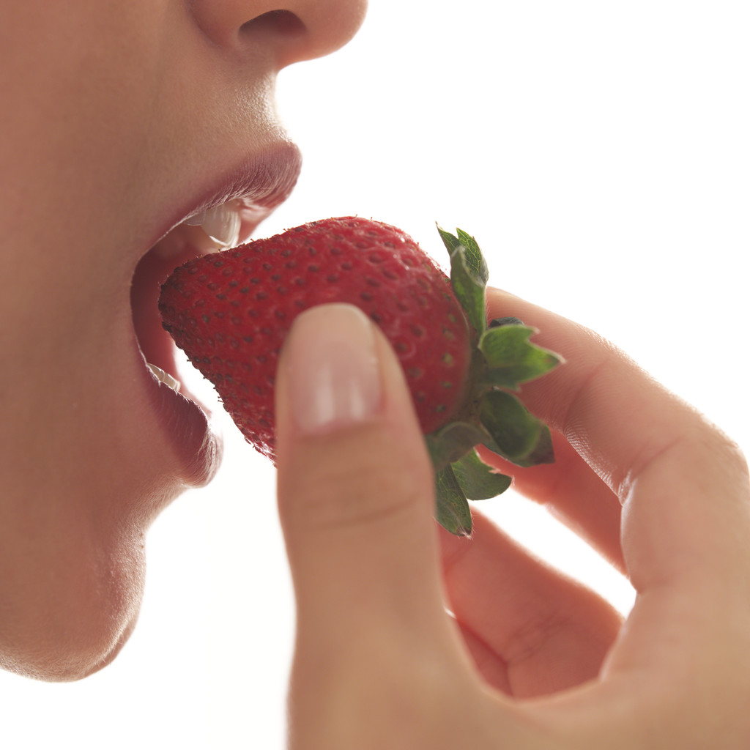
Learning objective
By the end of this lesson, you should be able to describe the sensory qualities of a variety of foods.

Keywords: senses, sensory qualities, taste, texture, appearance.

1) Which body senses are used when you eat food? Can you think of words that describe the food?

Senses | Sensory Qualities
Hearing | Crunch, crackle, sizzle, bubbling, crispy.

2) Work in pairs. Write the words you would use to describe the sensory qualities you would expect if you bought or made the following foods.

Food | Sensory Qualities
Bag of crisps

Chocolate milkshake

Salad

Vegetable lasagne

Did you know?
80% of decisions we make about food are based on appearance alone. We usually decide to buy a product because the packaging or the product looks good. Whether we buy it again largely depends on taste and texture.

Write your favourite recipe, equipment, ingredients and method below.

Practical 5: Victoria Cup Cakes with Glacé Icing

Learning Objectives
By the end of this task you should be able to:
- demonstrate the creaming method for making cakes;
- apply finishing techniques such as dusting, garnishes, and icing.

Keywords: chemical and mechanical raising agents, creaming method, finishing technique (dusting, garnishes, icing.)

Did you know?
Anna, the Duchess of Bedford (1788-1861) was one of Queen Victoria's ladies-in-waiting. She is known to be the creator of teatime. The Duchess often suffered from "a sinking feeling" at about 4pm and began inviting friends to afternoon tea. Queen Victoria adopted this new craze for tea parties, which still goes on at Buckingham Palace today and this simple sponge cake was one of the queen's favourites. It soon became known as the Victoria Sponge.
Ingredients  100g Margarine  100g Caster Sugar  100g Self-Raising Flour  2 Eggs (Lion Quality Eggs)  25g Jam  25g Icing Sugar |  | 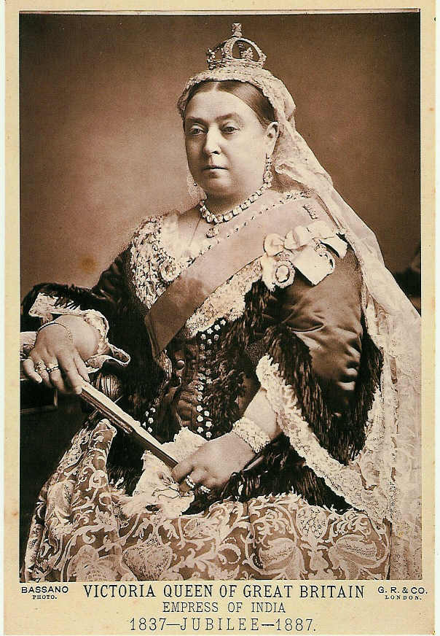  Equipment  1 scrap bowl  2 sponge tins  Large mixing bowls  Wooden spoon  Weigh scales  Measuring jug  Fork  Sieve  Palette knife  Cooling rack
Method
- Turn the oven on, gas mark 6 or 180^{c}. Grease and line two 6” sponge tins.
- Cream the margarine and sugar together.
- Add the beaten egg a little at a time, to the sugar and margarine mix.
- Sieve the flour and add gradually to the egg, margarine and sugar mix.
- Divide the mixture between your two prepared sponge tins and spread evenly with a palette knife.
- Bake for 15 – 20 minutes.
- When cooked turn out onto a cooling rack. (The cake is cooked if it springs back when touched with your fingertips).

Questions
- What raising agents are used in cake making? …………………………………………………………………
- An 8 inch cake tin (20cm) requires you to use 175g of self raising flour. Complete the quantities for the recipe below.
……… margarine
……… caster sugar
……… eggs
175g self-raising flour

- Explain why opening the oven door during baking can cause a cake to sink.
.……………………………………………………………………………………………………………………………
Practical 6: Roasted Stuffed pepper
with Savoury Rice or Cous-cous

Learning objectives
By the end of this task you should be able to:
- identify different types of vegetables and the category they are in;
- make a savoury cereal dish eg risotto or cous cous;
- use a specification to design and make delicious roasted stuffed vegetables.

Keywords: vegetable classification, roast, savoury, annotation, specification, control check.

  - give one example under each classification of vegetable
Bulb Vegetable | Root Vegetable | Tuber
Stem Vegetable | Leafy Vegetable | Flower Vegetable
Vegetable Fruit | Pulse Vegetable | Fungi
/8

  - Name a vegetable that begins with the following letters. Identify what type of vegetable it is, must be different from the above list?
Vegetable Name | Type of Vegetable (eg. Tuber)
P
B
F
R
T
/10

  - Draw a line to match the safety and quality control checks to the instructions for making stuffed peppers.

Cut the pepper and place it on a baking tray, Brush with olive oil and roast for 10 minutes. |  | Don’t over cook garlic otherwise it will burn and make the rice taste bitter.
Heat oil and butter in a frying pan and sweat the onion, then add the garlic and fry for 1 minute. |  | Use a wooden spoon not a metal spoon.
Add long grain rice, stir for 1 minute. |  | Tie your hair back. Wash your hands. Wear an apron.
Gradually add the warm stock by the ladle, allowing the rice to absorb the stock before you add more. |  | Use oven gloves not a tea towel.
When the rice is al dente, remove from the heat. |  | Wash vegetables. Cut on a green chopping board.
Remove the roasted vegetables from the oven.  Stuff to the vegetables with the rice and season with freshly ground black pepper. Sprinkle with grated cheese then bake in the oven for a further 15 minutes. |  | Stir continuously using a wooden spoon. This will give the rice a creamy texture and stop the rice from sticking to the pan.
Design Brief
Design two different ways to present Roasted Stuffed peppers. The Roasted Stuffed peppers must:
- have a savoury filling;
- have a finishing technique to improve appearance;
- have an interesting flavour to appeals to people who like a wide range of tastes;
- be a composite dish.

Design Idea 1: ……………………………………

…………………………………………………………………………………………………………………………………

Design Idea 2: …………………………………….

Assessment for Learning
Bronze – I have labelled sketches.
Silver – I have quality coloured and labelled sketches that meet most of the specification.
Gold – I have excellent drawings that are labelled and neatly coloured and clearly show how the product meets the specification and why ingredients have been used.
Plan of Make for Roasted Stuffed peppers

Choose one of your design ideas. Plan how you are going to make the meal. Suggest times.

Ingredients  ……………………………………………………………….  ……………………………………………………………….  ……………………………………………………………….  ……………………………………………………………….  ……………………………………………………………….  ………………………………………………………………. | Equipment  ……………………………………………………………….  ……………………………………………………………….  ……………………………………………………………….  ……………………………………………………………….  ……………………………………………………………….  ……………………………………………………………….
Method (Include these key words: Bridge hold, claw grip, dice, grate, sweat, boil, simmer, bake, stir continuously, prepare, wash, brush, finish.)

…………………………………………………………………………………………………………………………………..

…………………………………………………………………………………………………………………………………..

…………………………………………………………………………………………………………………………………..

…………………………………………………………………………………………………………………………………..

…………………………………………………………………………………………………………………………………..

…………………………………………………………………………………………………………………………………..

…………………………………………………………………………………………………………………………………..

…………………………………………………………………………………………………………………………………..

…………………………………………………………………………………………………………………………………..

…………………………………………………………………………………………………………………………………..

…………………………………………………………………………………………………………………………………..

…………………………………………………………………………………………………………………………………..

…………………………………………………………………………………………………………………………………..

Assessment for Learning. Working towards…  Bronze - I have written an ingredient list, instructions and selected appropriate equipment.  Silver – I have written an ingredients and equipment lists, detailed step-by-step instructions and included cooking times and temperature control.  Gold - I have been creative in my use of ingredients. I have written a step-by-step plan that includes cooking times, temperature control and explains how to know when some of the steps are ready. |  | Level for  this work
Starch is a thickening agent in stews and sauces
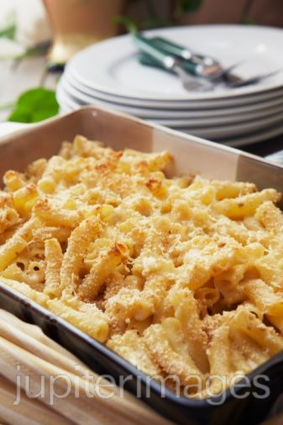
Sauces are an important food product. They add flavour, colour, moisture and nutritional value to food. Starch is found in wheat, corn, rice and potatoes and is a good source of carbohydrates which is needed for energy.

Starch has many useful properties such as:
- a thickening agent in stews and sauces
- a bulking agent (forms the bulk of a product such as bread, cakes, rice in stuffed vegetables)
- a gelling agent (eg. translucent shiny gloss on a fruit flan.)

Common food starches:

 Questions
For each of the following foods, state what type of starch is used and what their function is. (Think carefully, there are more starches found in these foods than the 3 starches listed above.) The first one has been done for you.

Macaroni cheese | Plain flour  Thickening agent |  | Lemon meringue pie
Lasagne cheese sauce |  |  | Chicken and mushroom pie
Leek and potato soup |  |  | Spinach, potato and chickpea curry
Risotto |  |  | Gravy

How does starch thicken a sauce?
Starch thickens a sauce by a process called gelatinisation. When the starch granule is heated with liquid (eg. water, milk), the granules absorb the liquid and swell and the mixture begins to thicken.

Rules for Gelatinisation of Starch Flours
Blending with a separating agent - starch (flour) must be blended with a separating agent before it is heated, otherwise the starch granules join together to form lumps. The separating agent may be:
- melted fat (eg. Melted butter in a roux.)
- cold water or another cold liquid such as milk
- other dry ingredients – such as sugar
Stirring – The product needs to be stirred continually when it is heated, otherwise the starch settles to the base on the saucepan and the sauce becomes lumpy.

Practical 7: Macaroni Cheese and Vegetable Bake

Learning objective
In this activity, you will:
- make a roux (blend of butter and flour sauce);
- understand the principle of starch as a thickening agent;
- apply a finishing technique known as crumbing/ enrobing;
- make a baked pasta dish.

Keywords: roux, béchamel, bake, separating agent, thickening agent, gelatinisation, enrobing.

Ingredients
Quantity | Ingredient | Function and/or Sensory Properties
250ml | Semi-skimmed milk
20g (about 1 tblsp) | margarine
15g (about 1 tblsp) | flour
80g | cheese (grated)
140g | Macaroni or other pasta
60g | Vegetable (eg. broccoli)

Method
- Preheat the oven to 200ºC / Gas Mark 6.
- Boil a saucepan of water. Add pasta and bring to the boil. In the last 5 minutes you should add hard vegetables to the macaroni.) Add soft vegetables such as peas and sweetcorn later.
- In another saucepan melt the butter over a medium heat then add the flour. Stir well with a wooden spoon. The mixture will be thick to start. This is called a roux.
- Gradually add the milk to the butter and flour mixture, stirring constantly. Add the milk slowly stirring after each addition. The sauce is now called a béchamel sauce. Simmer and stir the béchamel sauce until it has a rich, smooth consistency and is free from lumps.
- Add 2/3 grated cheddar to the béchamel and stir until melted and smooth. Turn off the heat. Once the cheese is added, don't allow it to boil or the cheese will become stringy. The sauce is now called a mornay sauce.
- Drain the pasta using a colander. Put the pasta back in the saucepan then pour the mornay sauce into the macaroni and mix together.
- Place the macaroni cheese into a shallow ovenproof dish (about 18cmx8cm) and sprinkle with remaining cheese. Bake it in the oven until golden brown, about 15-20 minutes.

Questions
1) Suggest two top tips for making a successful béchamel sauce?

2) Make a list of vegetables that would be suitable to add to macaroni cheese to make it a composite dish?

Evaluation of Ready-made and Home-made Macaroni Cheese

Assessment for Learning
- Bronce - write an evaluation and include strengths, weaknesses and suggestions for improvement.
- Silver - write a detailed evaluation, including strengths, weaknesses and suggestions for improvement (eg. suggest changes to ingredients and quantities and/or changes to cooking processes.)
- Gold – Understands processes and outstanding detail placed into task

Activity – Compare a ready made macaroni cheese and vegetable pasta bake
    - Decide on the success criteria for a macaroni cheese and vegetable pasta bake. Write the descriptive words on the product profile below. Use coloured pencil to evaluate a bought product.
    - After you have made your macaroni, use a different coloured pencil to evaluate your home-made dish on the product profile below.

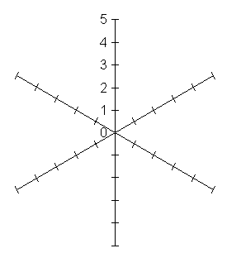

Use coloured pencils to identify the traffic light colours to compare the nutritional value of both dishes.
Macaroni Cheese per 100g
 | Home made with broccoli | Ready made
kJ | 600
Protein | 7.27g
Carbohydrate  - sugar  - starch | 1.06  19.58
Fat  Saturates | 4.27  1.9
Fibre | 2
Sodium | 0.14g

3) Tick the appropriate box on the hedonic scale for the two products.
Hedonic ranking scale | Like a lot   | Like a little   | Neutral   | Dislike a little   | Dislike a lot  
Ready made
Home made

4) What did you like about your macaroni cheese? (Describe appearance, taste and texture.)

5) What did you dislike about your macaroni cheese? (Describe appearance, taste and texture.)

6) Suggest three ways you could develop (improve) your macaroni cheese? (Nutrition, appearance, taste and texture.)

Price Comparison

Calculate the cost of making macaroni cheese

Price 400g Macaroni cheese at Sainsbury’s = £1.99 (serves 1)

Calculate the cost of making the macaroni cheese yourself. The recipe below makes enough for 2 people. Note that in the last row the value of the currency is in pounds not pennies!

Example:
1.5kg of plain flour costs 43p but the recipe only uses 15g.
43p ÷ 1500g = 0.029p per gram of flour
0.029p x 15g flour= 0.43p (less than ½p for 15g of flour)

Ingredients  (in grams, ml or number) | Price | Cost per unit | Quantity used | Price to make at home
15g plain flour | 43p | 43p ÷ 1500g= 0.029 / gram | 15g | 0.029p x 15g= 0.43p
20g butter or margarine | 69p | 69p ÷ 250g= _________ / g | 20g | _______ x 20g= ______p
250ml milk | 45p | 45p ÷ 568ml= _________ / ml | 250ml
140g macaroni | 60p | 60p ÷ 500g= _________ / g | 140g
80g cheddar cheese | £4.81 | £4.81p ÷ 1000g= _________/g | 80g
1 slice of bread | 79p for 800g |  | 1 slice
 |  |  | TOTAL=

Questions
1. Is it cheaper or more expensive to make the macaroni cheese? Explain why.

2. List three advantages of making the macaroni cheese yourself.

3. Suggest two ways a product developer might lower the cost of manufacturing the ready-made macaroni cheese so that they can make more profit.

Omelette

Make a list below of 10 additional ingredients that would be good to flavour omelette

Ingredients

1 egg, beaten
1 tsp sunflower oil
1 tsp butter

Method
Season the beaten eggs well with salt and pepper. Heat the oil and butter in a non-stick frying pan over a medium-low heat until the butter has melted and is foaming.

Pour the eggs into the pan, tilt the pan ever so slightly from one side to another to allow the eggs to swirl and cover the surface of the pan completely. Let the mixture cook for about 20 seconds then scrape a line through the middle with a spatula.

Tilt the pan again to allow it to fill back up with the runny egg. Repeat once or twice more until the egg has just set.

At this point you can fill the omelette with whatever you have planned

Which recipes did you enjoy making? | Like a lot | Like a little | Neutral | Dislike a little | Dislike a lot
Vegetable soup
Classic tomato and basil penne
Fresh farmhouse bread rolls
Vegetable Supreme Pizza
Victoria Cup Cakes
Roasted Stuffed Vegetables
Macaroni cheese and vegetable pasta bake

Design & Technology -
(Food Technology) Self-Assessment
Name |  |  | Form |  |  |  |  |  | Tech Group
Targets (from last project) |  |  |  |  |  |  |  |  | Last level achieved
Tick the box that best describes how you feel about each part of your food project |  |  |  | ☺  very  pleased |  | ☺  pleased |  | 😐  fairly  happy |  | ☹  unhappy |  | I did NOT do this part
Designing | I sketched various ideas and feel…………
Planning | I planned my making and feel…………
Making | I feel … with my food preparation and cooking skills.
Evaluating | I evaluated my work and feel…………
Did you meet your targets from last the project? |  |  |  |  |  |  | Yes |  |  |  | No
Student Comment (describe what you could do to improve.) |  |  |  |  |  |  | Your level |  |  |  | Teacher level
Teacher Assessment |  | Excellent |  |  | Good |  | Satisfactory |  |  |  | Needs improving
Effort
Classwork
Homework
Behaviour
Targets  Design Ideas  - Explain how your ideas match the specification.  - Consider size/ colour/ how you are going to make it/ ingredients and why you chose them.  - Use notes to develop your ideas fully.  Planning  - Do a plan of make.  - Include ingredients/ quantities/ equipment/ key words/ times/ temperature/ information on how to know when each step is ready.  General  - Complete all work (to a high standard.)  - Read and respond to the teacher’s comments.  - Always complete your homework.  - Improve presentation. Use pencil. Write in black or blue pen.  - Improve attendance/ behaviour. |  | Making  - Bring ingredients.  - Improve knife skills (bridge hold/ claw grip.)  - Take greater care following instructions.  - Work faster.  - Use finishing techniques to improve appearance.  Evaluation  - Do an evaluation/ quality report on your food.  - Evaluate good and bad points (taste, texture etc)  - Suggest improvements.  - Explain what affect you expect your suggested improvements will have to your designs.  - Be more specific about the ingredients or method you would change.
Teacher Comment

Teacher Signature Date

Environmental impacts around the world
Complete a poster of plastics, how this is effecting the planet, what we can do to help it, research what is being done now and in the future

Complete a spider diagram of ideas on how you will complete your homework

