Name

Class

**1** Draw a mental map of your local area. Take a few minutes to think about the area and picture it in your mind. Draw a rough sketch on a separate piece of paper and **identify** the main features (buildings, trees, roads). Then draw a neat version in the space below using colours. Label the main features.

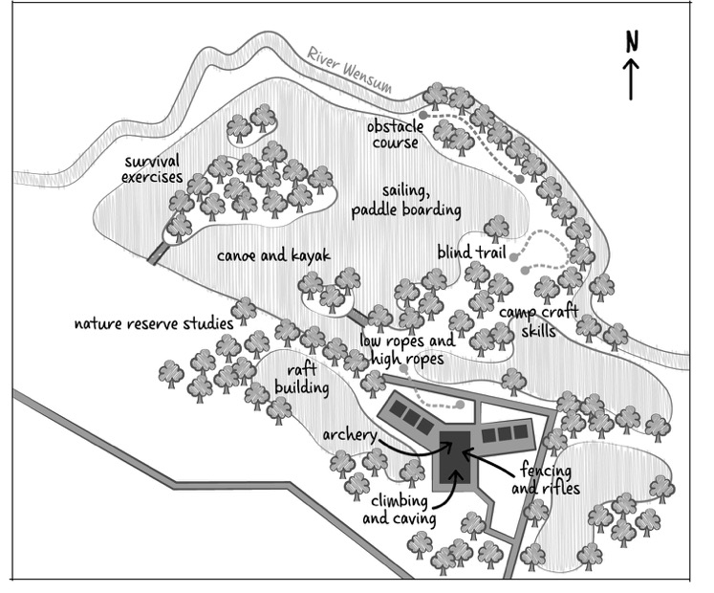

Sketch map of Norfolk Lakes adventure park, Norfolk



**2** Look at map **D**. Notice that there are lots of activities on offer at the adventure park, both on and off the water.

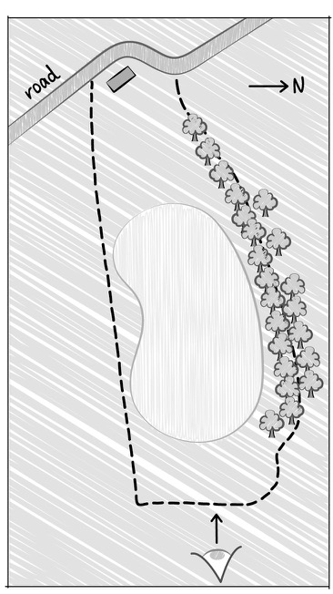

(a) Design a children’s adventure park. Use map **D** to give you some ideas. You can add your own ideas too. Do a rough plan on a separate piece of paper to start with, and then produce your neat sketch map on map **E** below.

Sketch map of Cawfields Quarry, Northumberland

(b) Write a few sentences to **justify** your design.

To justify your design, you need to give reasons for the choices you have made. For example, why have you chosen a particular activity for the wooded area?

Tip!

(c) In no more than 100 words, write a short advert to encourage people to visit your adventure park.