**Ecosystems**

Use the internet to research for answers for some of these questions <https://www.bbc.co.uk/bitesize/topics/z2tqwxs>

1. Explain and describe the features of a small-scale ecosystem in the UK. (4marks)

2. Using the diagram below answer the following questions:

a) Which of the following statements is correct? (1mark)

i) Most areas of tundra are found on the edges of land masses

ii) The largest polar area is found north of the equator

iii) There are no areas of tundra south of the equator

iv) There are no polar areas south of the Tropic of Capricorn

b) Which of the following statements is correct? (1mark)

i. There is a greater area of hot desert in the Southern Hemisphere than the Northern Hemisphere.

ii. The largest single area of tropical rainforest is in South America

iii. Temperate deciduous forests are all found on the western side of continents

iv. Hot desert areas are all found between the two tropics

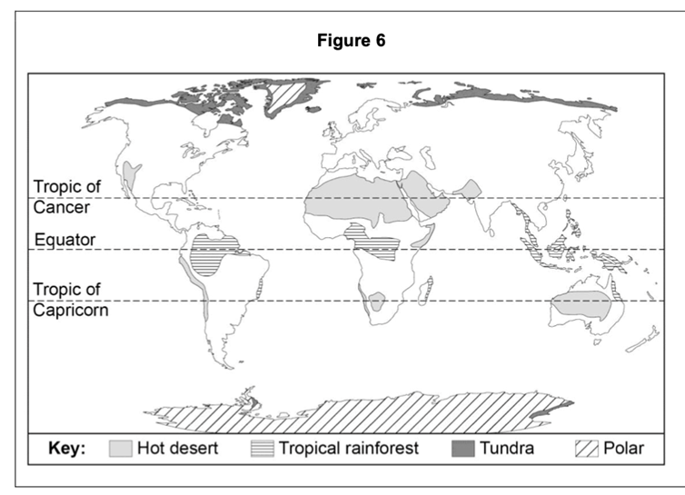

3) Outline one reason for the distribution of tropical rainforest (2marks)

4. Describe the distribution of hot deserts shown (2marks)

5) Describe and explain the main plant adaptions in a tropical rainforest environment (4marks)

6) Give one characteristic of the base of taller trees (1mark)

7) Describe and explain the features of the vegetation shown in the diagram to the right (6marks)

8) Which one of the following statements describes the climate of a tropical rainforest? (1mark)

a) Mild temperatures (10-18 degrees), rainfall all year (approx. 1000mm)

b) High temps all year (over 30degrees), very dry (250mm rainfall per year)

c) High temps all year (25-27 degrees), rainfall in every month (1800-2000mm per year)

d) Wide range of temperatures (15-30 degrees), seasonal rainfall (approx. 750mm)

9) Using the figure provided, which part of the rainforest matches the following description?

‘An almost continuous layer of branches and leaves between 15 and 30 metres high’ (1mark)

a) Emergent layer

b) Unpper canopy

c) Lower canopy

d) Lower canopy

e) Understory

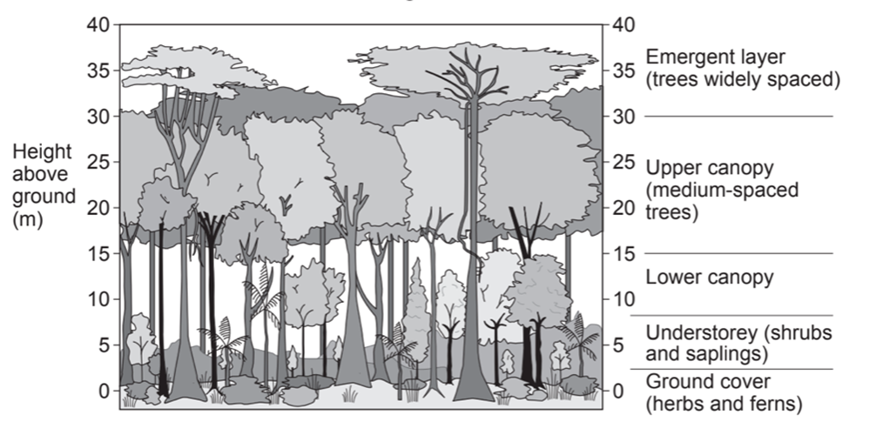

18) Study the figure below, showing deforestation in Borneo (SE Asia) between 1980 and 2020.

a) Complete the pie chart for 2020 (estimate) using the following information (1mark)

- Rainforest = 35%. – Deforested area = 65%

b) Suggest two reasons why the rate of deforestation varies between different countries (2marks)

