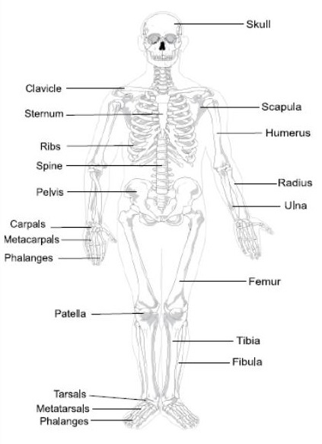Functions of Skeleton

1. Support
2. Movement
3. Protection
4. Storage of Minerals
5. Blood Cell Production
6. Shape

Axial Skeleton is the bones in the centreline on skeleton

Cranium, Vertebrae, Ribs and Sternum

Appendicular Skeleton is the arms and legs

Types of Bone

1. Long - humerus, femur
2. Flat - ribs, sternum, scapula – protection
3. Irregular - vertebrae – irregular shape
4. 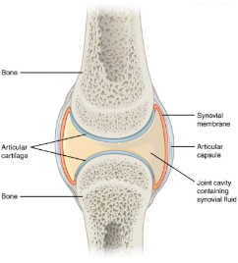Short - carpals, tarsals – Stability
5. Sesamoid – patella. –encapsulated by a tendon

Types of Joints – ‘A Joint is where 2 or more bones meet’

1) Fixed EG Cranium

2) Slightly Moveable EG Vertebrae

3) Synovial Joint (freely moveable) EG Ball and Socket

|  |  |  |
| --- | --- | --- |
| *Types of Synovial Joints* | | |
| Name | Example | Movement |
| Hinge | Knee and elbow | Flexion, extension |
| Ball and Socket | Shoulder and hip | Flexion, extension, abduction, adduction, rotation. |
| Condyloid | Wrist | Side to side and forwards and back |
| Saddle | Thumb | Side to side and forwards and back |
| Gliding | Clavicle | Gliding movements |
| Pivot | Neck | Atlas meets axis in neck (Head Rotation) |

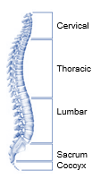

|  |
| --- |
| Joint Movements and Description |
| Flexion – decreasing angle at joint |
| Extension – increasing the angle at a joint |
| Adduction – movement towards the centre/mid line |
| Abduction – movements away from the centre/mid line |
| Rotation – twisting movement |

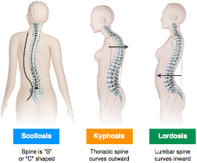

Isometric Muscle Contraction is when the muscle contracts and the stays the same length. E.g. crucifix in gymnastics

Isotonic Eccentric Muscle Contraction is when the muscle contracts and lengthens. E.g. lower a weight in a gym.

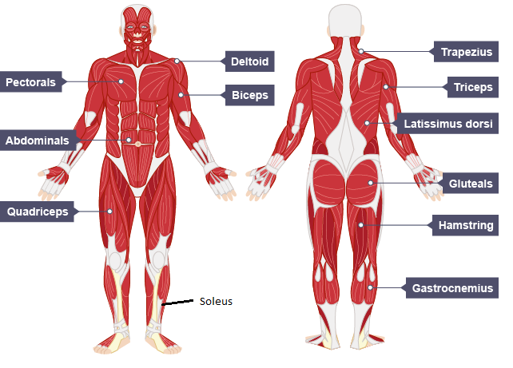Isotonic Concentric Muscle Contraction is when the muscle contracts and shortens. E.g. lifting a weight in the gym.

Types of Muscle

1. Cardiac E.g. Heart - aids blood flow
2. Smooth E.g. intestines – aids digestion
3. Skeletal E.g. Bicep - Movement

|  |  |  |
| --- | --- | --- |
| Types of Skeletal Muscle | | |
|  | Characteristics | Sporting example |
| Type 1 – Slow Twitch Fibres | Does not fatigue quickly. Lots of mitochondria. Red in colour | Long Distance runner |
| Type 2 - Fast Twitch Fibres | Fatigue very quickly. No mitochondria. White in colour | Usain Bolt – 100m sprinter |

Antagonistic Pairs - Muscles work in pairs. When one contracts the other relaxes

Agonist is the prime mover. It is the muscle that contracts.

Antagonist is the muscle that relaxes in the pair.

E.G. in a bicep curl the bicep is the agonist, triceps is the antagonist

Alveoli are the site of gas exchange and diffusion occurs here

They are good at their job because there is…..

1. Lots of them
2. 1 cell thick
3. Large surface area

|  |  |  |
| --- | --- | --- |
|  | Inspiration | Expiration |
| Volume of air | high | low |
| Diaphragm | Contracts and flattens | Relaxes and goes into a dome |
| Intercostal Muscles | Contracts and raise ribs | Relaxes and lowers ribs |

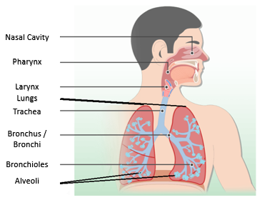

Diffusion – is movement from a high concentration to a low concentration  
Gas Exchange - is the process in the alveoli where oxygen is breathed into the body and carbon dioxide is breathed out.

Tidal Volume is the amount of air that enters the lungs in a normal breath at rest.

Breathing Rate is the number of breaths per minute

Residual Volume is the amount of air left in the lungs after maximal exhalation.

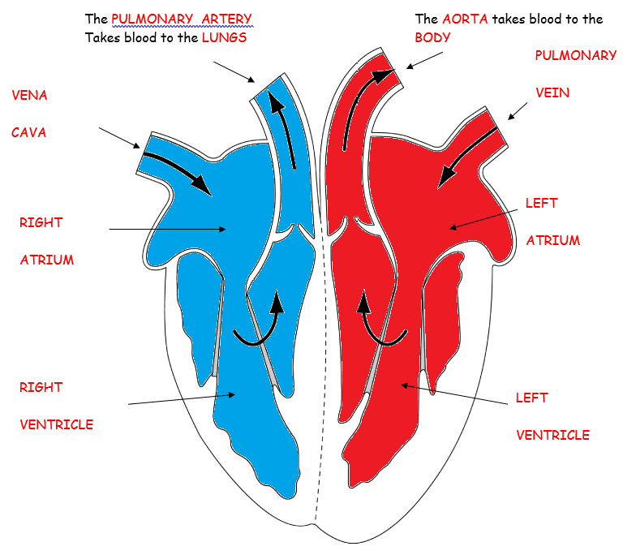Vital Capacity is the maximum amount of air that can be forcible breathed out after maximum inspiration

|  |  |  |
| --- | --- | --- |
| **Blood Vessels** | Characteristics | Towards / Away |
| Veins | Thin Wall, Contain Valves, Under low Pressure, Large oval Lumen | Towards |
| Arteries | Thick muscular wall, Under high pressure | Away |
| Capillaries | One cell thick, Site of Diffusion and gas exchange, Small circular lumen | Towards and Away |

**Key definitions**

Vascular Shunting – the process of redistributing blood through vasoconstriction (Narrowing vessels) and vasodilation (Widening vessels).

Heart rate – Number of times the heart beats per minute

Maximal heart rate equation – 220 – Age =

Stroke volume – the amount of blood pumped out of the left ventricle per beat

Cardiac output - the amount of the blood pumped through the heart per minute

Cardiac output equation

HR X SV = Q (CO)

Cardiac Cycle

1) Deoxygenated blood from the body

2) Vena cava

3) Right atrium

4) Right ventricle

5) Pulmonary artery

6) To the lungs to pick up oxygen and nutrients to become oxygenated from the lungs

7) Pulmonary vein

8) Left atrium

9) Left ventricle

10) Aorta

11) To the body to drop off oxygen and nutrients

12) Pick up waste products and become deoxygenated.

Good Blood Pressure is 120/80

Systolic Blood Pressure - the pressure on the arteries during a heartbeat -120

Diastolic Blood Pressure – the pressure on the arteries between heartbeats -80

Factors that affect blood pressure. This includes:

1. Activity levels
2. Diet
3. Age
4. Stress.

**1.5 Energy Systems**

Aerobic Energy system is USING OXYGEN

Aerobic Energy system Equation – Glucose + Oxygen = Energy + Water +Co2

ANAEROBIC Energy system is NOT USING OXYGEN

Anaerobic Energy system Equation – Glucose = Lactic Acid + Energy

**LO1**

|  |
| --- |
|  |

|  |  |  |
| --- | --- | --- |
| Short Term Effects | Definition | Why does it occur |
| Breathing rate | The number of breaths per minute | There is an increased amount of oxygen needed in lungs and a need for respiration. |
| heart rate | The number of times the heart beats in a minute | There is an increase in heart rate due to increase need of the supply of nutrients, oxygen and removal of waste. |
| stroke volume | The amount of blood pumped through the left ventricle per beat | Stroke volume increase slightly to supply more blood per beat to the |
| cardiac output | The amount of blood pumped through the left ventricle per minute SV x HR = Q (CO) | Cardiac out increase to increase the amount of blood going through the heart per beat. This is so that |
| blood pressure | The pressure of blood on the walls of the arteries. This can be divided into systolic and diastolic | Blood pressure increase due to the heart pumping harder and faster during exercise |
| body temperature | Core body temperature is 37 degrees C when at normal rest | Body temperature rises as a result of increased respiration. Up to 70% of the energy is lost as heat in the body. |
| hydration levels | Hydration refers to the amount of water within the body at any one time. on average people will need 2 – 2.5 litres of water to keep themselves hydrated | Hydrations decrease during exercise. This is due to the fact that water is lost through sweat and bodily processes. Blood become more thick and decision processes can be affected negatively |
| muscle fatigue | Fatigue refers to Muscle become tired over short term. | There is a build-up of lactic acid and muscle function can be negatively affected Muscle fibres |
| delayed onset of muscle soreness | DOMS or delayed onset of muscle soreness. This occurs after an event or activity | 24 -48 hours after exercise pain is felt sue to micro tears within the muscles. Ice baths and heat packs can help to reduce this |

|  |  |  |
| --- | --- | --- |
| Long term effects | Definition | Why does it occur |
| Cardiovascular endurance | Cardiovascular endurance the ability for you your heart, blood vessels, and lungs to supply oxygen rich blood to working muscles during physical activity. | Cardiovascular endurance will increase due to increase in efficiency. Your heart will become larger (Hypertrophy) |
| efficiency to use oxygen | Increase in oxygen efficiency results in oxygen being taken in transported and used quicker and without delay | Body adapt to use oxygen in a better way. This will result in more respiration occurring and energy being harnessed more efficiently |
| blood pressure | The pressure of blood on the walls of the arteries. This can be divided into systolic and diastolic | Lower blood pressure means that more blood can be pumped per beat |
| resting heart rate | The number of time the heart beats per minute at rest | Lower resting heart rate is known as Bradycardia. |
| muscular endurance | The ability to work muscles or groups of muscles for a long period of time without fatigue | Muscles adapt to contract repetitively for a longer period of time |
| muscular strength | Muscular strength is the ability for the muscles to exert a force against a resistance | Muscles being stronger |
| muscle hypertrophy | Muscle Hypertrophy is an increase in muscle size and strength. | Muscle Hypertrophy will result in larger muscles and turn more capability to perform at a higher and longer intensity |
| red blood cells | Red blood cells are within blood and carry oxygen on haemoglobin | More Red blood cells mean more haemoglobin. This will mean more oxygen can be picked up and carried to working muscles |
| Flexibility | Flexibility is the range of movement at a joint | Flexibility increases due to muscles become stretched over time. therefore increasing the range of movement |
| body shape (endomorph/ectomorph/mesomorph | Body shape  Endo morph – Fat  Ectomorph – Skinny  Mesomorph – Muscular | When exercising body shapes will naturally tone up and move from endo to meso. And endo to meso |

**LO2**

Health is a complete balance of physical, mental and social wellbeing. Not merely the absence of injury of illness

Fitness is the ability to meet the needs of your environment

You need a balance of physical, mental and social to be healthy. Can’t just have 2 of them

A Sumo wrestler can be considered being fit

Health Related Fitness Components

|  |  |  |
| --- | --- | --- |
| Component | Definition | Sporting Example |
| Body composition | A comparison of the percentages of bone, fat, water and muscle in the body | Endomorph – Sum Wrestler  Ectomorph – Marathon Runner  Mesomorph – Rugby Player |
| Muscular endurance | The ability to work muscles or groups of muscles for a long period of time without fatigue | 1500m runner in a race |
| Muscular Strength  Static – maximal strength  Dynamic – repeated contraction to a moving object  Explosive – quick movement e.g. jumping (power) | Muscular strength is the ability for the muscles to exert a force against a resistance | A Weight lifter doing a 1 Rep max in a gym |
| Flexibility | The range of movement at a joint | A Gymnasts doing the splits in a routine |
| Cardiovascular endurance | Cardiovascular endurance the ability for you your heart, blood vessels, and lungs to supply oxygen rich blood to working muscles during physical activity. | A marathon Runner working aerobically completing an event. |

Skill Related Fitness Components

|  |  |  |
| --- | --- | --- |
| Component | Definition | Sporting Example |
| Agility | The ability to change direction at speed | In rugby dodging an opponent to get around them. |
| Balance | The ability to maintain centre of mas over base of support | Static – Gymnast hold a head stand  Dynamic Balance – running through tyres on an obstacle course |
| Co-ordination | The ability to use 2 or more limbs simultaneously | Juggling 3 cricket balls |
| Power | The ability to strength activities quickly  Power = Strength x Speed | Jumping for a rebound in basketball |
| Reaction Time | The time taken from the presentation of the stimulus to the reaction of the onset of a reaction | Start of a Sprinting race when the gun goes and the athlete reacts |
| Speed | The ability to cover a long distance in a short space of time | Usain bolt running in 100 metres |

**LO3**

|  |  |  |
| --- | --- | --- |
| Principles of Training | Definition | Link to a sport |
| Specificity | Training will need to be specific to the needs of the individual | A Diver must practice diving and not swimming |
| Progressive Overload | Progressive – Gradually increasing the level of work  Overload –working harder than normal | Completing a gym session and increasing the amount that is lifted each week gradually |
| Reversibilty | If an individual stops or reduces their training level, their fitness is likely to drop | If you get injured and break a bone you are likely to lose what you have gained |
| Tedium | This refers to boredom. If you are doing the same thing each time athletes will get bored | Always practicing passing in football will result in you getting bored |

|  |  |  |
| --- | --- | --- |
|  | Definition | Sporting example |
| Frequency | How often | training 3 times a week |
| Intensity | How hard | Working 60-80% of max heart rate |
| Time | How Long | Working for 30 minutes each time |
| Type | What type of activity | Completing the activity in the sport of football |

**LO4**

THE KEY TO ANSWERING 6, 8, 9 Mark Answers

1. Underline key words in question
2. Define key terms
3. Link to question statement
4. Justify your point

**LO4**