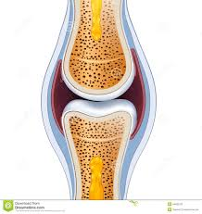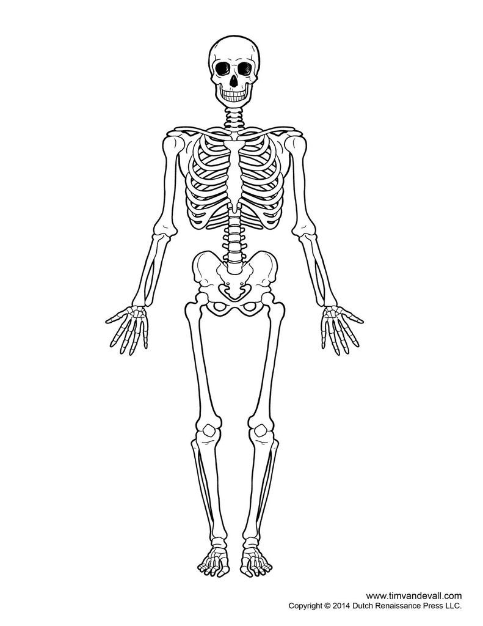

Give a long term benefit of regular exercise on the skeleton?

C

S

R

V

Bones in Appendicular skeleton – Lower body

P

F

T

F

Ta

PH

Synovial Joint

Articular C……………..

Li

Te

Joint C………………..

Synovial M……………

Synovial F……………………

Functions of the skeleton

S

M

P

B

S

UNIT 1 REVISION – Skeletal system

What is the main function of a

Long bone

Flat bone

Short bone

What is the role of a tendon?

What is the role of a ligament?

Give an example of a long bone

Short Bone

Irregular bone

Flat bone

Sesamoid

The main function of the vertebrae

Bones in Appendicular skeleton – Upper body

C

S

H

R

U

Ca

PH

Bones in Axial skeleton

C

S

R

V

Five types of bone

L

F

I

S

Ses

three types of posture

Ky

Lo

Sc

Five types of movement

Fl

Ex

Ro

Ad

Ab

Spine

Cer

Th

Lu

Sa

Co

Six types of joint

Pi

Con

Sa

Gl

ba

Hi