Name

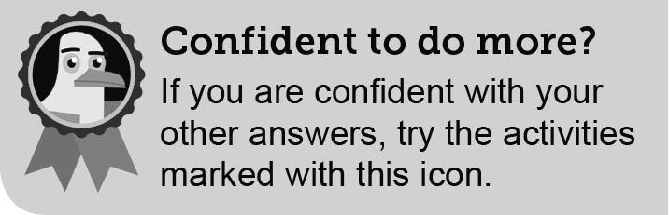

Class

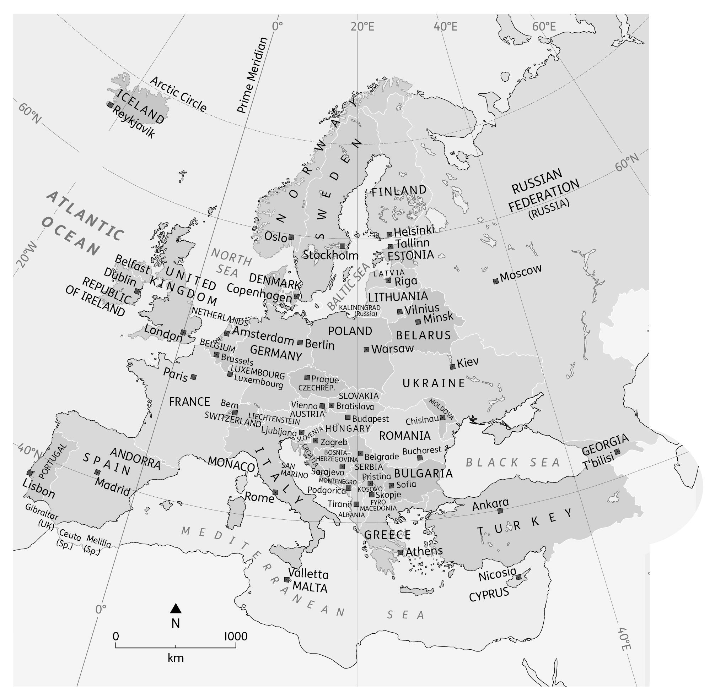

The countries and capital cities of Europe

1. Look at Table **K**. Use map **A** to help you **complete** the table by filling in the gaps.

|  |  |  |
| --- | --- | --- |
|  | Country | Capital city |
| 1 | *GERMANY* | *B ___ R L ___ N* |
| 2 | *I ___ ___ L Y* | *___ O ___ E* |
| 3 | *F ___ N ___ ___ N D* | *HELSINKI* |
| 4 | *B U ___ ___ A R ___ A* | *SOFIA* |
| 5 | *___ O ___ T ___ G A ___* | *___ I S ___ ___ N* |
| 6 | *S ___ R B* | *BELGRADE* |
| 7 | *L ___ T ___ U ___ N ___ A* | *___ I L ___ I U ___* |
| 8 | *___ ___ E E ___ ___* | *A ___ H ___ ___ S* |
| 9 | *NETHERLANDS* | *___ M ___ T ___ R D ___ ___* |
| 10 | *___ C E ___ A ___ ___* | *___ ___ Y K J ___ V ___ K* |

European countries and their capital cities

**2** Use map **A** to help you answer the following questions.

(a) Locate Poland. Does it share a border with Ukraine?

Yes No

(b) Which area of sea forms Ukraine’s southern border?

(c) Some people think Istanbul is the capital of Turkey. Is that correct?

Yes No

(d) Of which country is Nicosia the capital?

(e) Several European countries border the Mediterranean Sea. **Identify** (name) one beginning with the letter ‘A’.

(f) Which sea would you cross if you took a ferry from Tallinn to Helsinki?

(g) Find Gibraltar in the south of Spain. Which country does Gibraltar belong to?

(h) How many countries border the Czech Republic?



**3** (a) **Give** two advantages of constructing the Channel Tunnel.

1

2

(b) The UK imports many cars from Europe. Can you **give** three European car companies?

1

2

3

(c) **Explain** (give reasons for) why the UK imports a lot of fruit such as oranges, lemons, grapes and melons from countries in southern Europe.

(d) **Suggest** (think about and say) why Europe is a popular destination for people from the UK.



(e) **Explain** how students can benefit from links between the UK and Europe.

|  |  |
| --- | --- |
| European country visited | UK tourists (millions) |
| Spain | 16.0 |
| France | 9.0 |
| Italy | 4.0 |
| Republic of Ireland | 3.5 |
| Germany | 3.0 |
| Portugal | 3.0 |
| Poland | 2.5 |
| Netherlands | 2.5 |
| Greece | 2.5 |
| Belgium | 1.5 |

Top ten European countries visited by UK residents in 2017



**4** Use the data in table **L** to complete the pictogram showing the most popular European   
countries visited by people from the UK.

(a) Using a scale of one person = 1 million UK residents, draw the correct number of people   
icons for each of the countries listed in the table. For some countries you will need to draw   
half a person! The first three have already been done for you.

