**BTEC Revision**

**Guide**

**Muscular System**

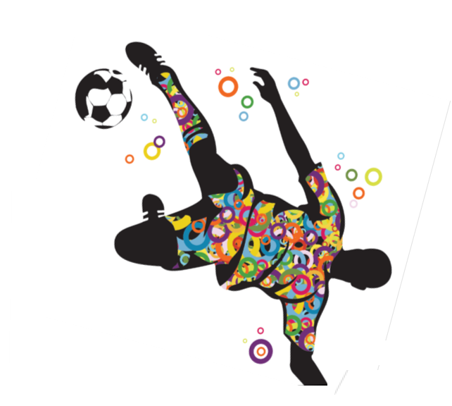

**B The effects of exercise and sports performance on the muscular system**

**B1 Characteristics and functions of different types of muscles**

|  |  |  |
| --- | --- | --- |
| **Type of Muscle** | **Characteristics** | **Examples** |
| Skeletal  Muscle | * Consciously controlled * They fatigue during exercise * Contract by impulses sent by the brain * Skeletal muscles contract which pull on bones to create movement | Biceps  Triceps  Deltoids  Gluteals |
| Cardiac  Muscle | * Unconsciously controlled * Does not fatigue * Only found in the walls of the heart * Cardiac muscles help circulate blood through and out of the heart | The walls of the heart |
| Smooth  Muscle | * Unconsciously controlled * They are controlled by the nervous system * Control body functions such as: the movement of food and blood | Arteries  Veins  Bladder  Stomach  Intestines |

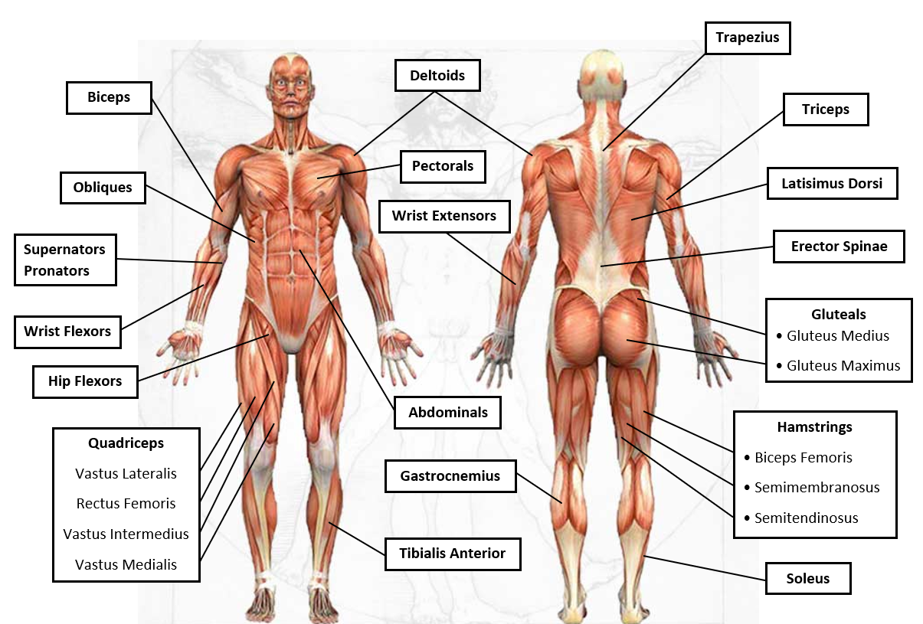**B2 Major skeletal muscles of the muscular system**

**Muscles Information**

|  |  |  |  |  |  |
| --- | --- | --- | --- | --- | --- |
| **Muscle** | **Function** | **Location** | **Origin** | **Insertion** | **Activity** |
| **Biceps** | Flexion of the Lower Arm at the Elbow | Front of Upper Arm | Scapula | Radius | Bicep Curl, Pull-Ups |
| **Triceps** | Extends Lower Arm | Outside Upper Arm | Humerus and Scapula | Olecranon Process | Dips, Press-Ups, Overhead Pressing |
| **Supinators** | Supinate the Forearm | Top and Rear of Forearm | Humerus | Ulna | Back Spin in Racket Sports, Spin Bowl in Cricket |
| **Pronator** | Pronate the Forearm | Top and Front of Forearm | Humerus | Ulna | Top Spin in Racket Sports, Spin Bowl in Cricket |
| **Wrist Flexors** | Flexion of the Hand at the Wrist | Front of Forearm | Humerus | Metacarpal | Bouncing a Basketball When Dribbling |
| **Wrist Extensors** | Extension or Straightening of Hand at Wrist | Back of Forearm | Humerus | Metacarpal | Straightening of Wrist |
| **Trapezius** | Elevates and Depresses Scapula | Large Triangular Muscle at Top of Back | Continuous Insertion Along Acromion | Occipital Bone & all Thoracic Vertebrae | Shrugging & Overhead Lifting |
| **Deltoids** | Abducts, Flexes and Extends Upper Arm | Forms cap of shoulder | Clavicle, Scapula and Acromion | Humerus | Forward, Lateral & Back-Arm Raises, Overhead Lifting |
| **Pectorals** | Flexes and Adducts Upper Arm | Large Chest Muscle | Sternum, Clavicle & Rib Cartilage | Humerus | All Pressing Movements |
| **Latissimus Dorsi** | Extends and Adducts Lower Arm | Large Muscle Covering Back of Lower Ribs | Vertebrae and Iliac Cest | Humerus | Pull-Ups, Rowing Movements |

|  |  |  |  |  |  |
| --- | --- | --- | --- | --- | --- |
| **Muscle** | **Function** | **Location** | **Origin** | **Insertion** | **Exercise** |
| **Obliques** | Lateral Flexion of Trunk | Waist | Pubic Crest & Iliac Crest | Fleshy Strips to Lower Eight Ribs | Oblique Curls |
| **Abdominals** | Flexion and Rotation of the Lumbar Region | ‘Six-Pack’ Muscle Running Down Abdomen | Pubic Crest & Symphysis | Xiphoid Process | Sit-Ups |
| **Erector Spinae** | Extension of Spine | Long Muscle Running Either Side of Spine | Cervical, Thoracic & Lumbar Vertebrae | Cervical, Thoracic & Lumbar Vertebrae | Prime Mover of Back Extension |
| **Gluteals** | Extends Thigh | Large Muscle on Buttocks | Ilium, Sacrum & Coccyx | Femur | Knee-bending Movements, Cycling, Squatting |
| **Quadriceps**  • Rectus Femoris  • Vastus Lateralis  • Vastus Medialis  • Vastus Intermedius | Extends lower Leg and Flexes Thigh | Front of Thigh | Ilium & Femur | Tibia & Fibula | Squats, knee bend |
| **Hamstrings**  •Semimembranosus  • Semitendinosus  • Biceps Femoris | Flexes Lower Leg and Extends Thigh | Back of Thigh | Ischium and Femur | Tibia and Fibula | Leg Curls, Straight Leg Deadlift |
| **Hip Flexors** | Flexion of Hip Joint (Lifting Thigh at Hip) | Lumbar Region of Spine to Top of Thigh | Lumbar Vertebrae | Femur | Knee Raises, Lunges, Squat Activation |
| **Tibialis Anterior** | Dorsiflexion of Foot | Front of Tibia on Lower Leg | Lateral Condyle | By Tendon to Surface of Medial Cuneiform | All Running & Jumping Exercises |
| **Soleus** | Plantar Flexion | Deep to Gastrocnemius | Fibula and Tibia | Calcaneus | Running & Jumping |
| **Gastrocnemius** | Plantar Flexion of foot | Large Calf Muscle | Femur | Calcaneus | Running, Jumping and Standing on Tip-Toe |

**B3 Antagonistic muscle pairs**

When a muscle contract, it exerts a pulling force on the bones to create movement. Under normal circumstances the muscles are in a state of partial contraction, ready to react to a stimulus from your nervous system. When a stimulus from the nervous supply occurs, muscle fibres work on an ‘all or nothing‘ basis – either contracting completely or not at all.

When a muscle contracts, one end remains stationary **(origin)** the other moves **(insertion).**

Muscles do not work on their own, they are assembled in groups and work together to create movement. They only act by contracting and pulling, they do not push.

Many muscles work in antagonistic pairs. When one muscle contracts the other relaxes. The muscle that contracts is called the agonist and the muscle that relaxes is called the antagonist

**Example**

**The biceps and triceps work together.**

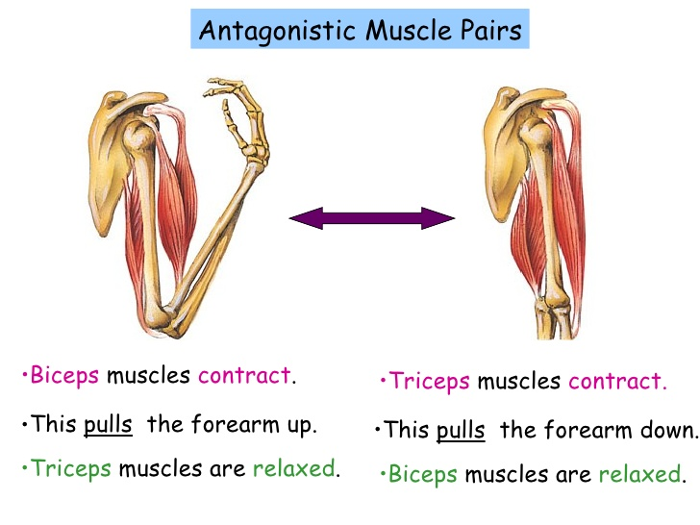

When we straighten the elbow (extension) the triceps contract and the biceps relax

Agonist = Triceps

Antagonist = Biceps

When we bend the elbow (flexion) the biceps contract and the triceps relax

Agonist = Biceps

Antagonist = Triceps

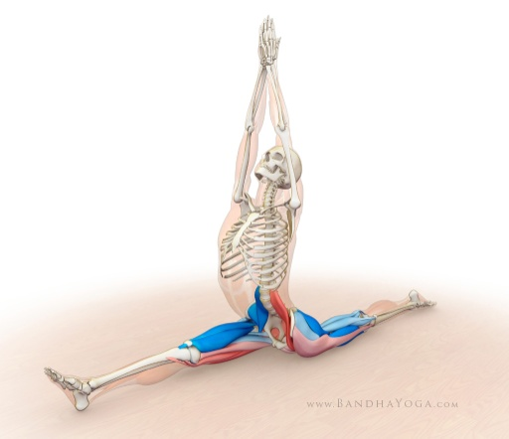**Antagonistic muscle pairs**

* Biceps – Triceps
* Quadriceps – Hamstrings
* Gluteals – Hip Flexors
* Gastrocnemius – Tibialis Anterior
* Wrist Flexors – Wrist Extensors
* Pronators – Supernators
* Abdominals – Erector Spinae

**Joint:** Hip (ball & Socket)

**Joint Movement**: Extension

**Agonist:** Gluteals

**Antagonist:** Hip Flexors

**Origin:** Pelvis

**Insertion:** Top of Femur

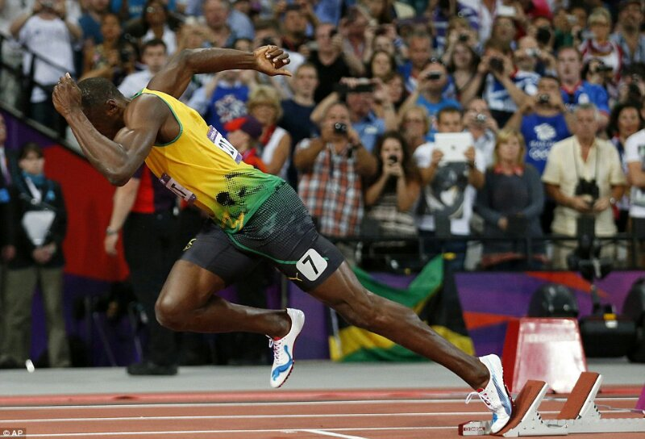

**Joint:** Knee (Hinge)

**Joint Movement**: Flexion

**Agonist:** Hamstring

**Antagonist:** Quadriceps

**Origin:** top of Femur

**Insertion:** Tibia, Fibula

**Joint:** Ankle

**Joint Movement**: Plantar Flexion

**Agonist:** Gastrocnemius

**Antagonist:** Tibialis Anterior

**Origin:** Tibia, Fibula

**Insertion:** Tarsals

**Synergists:** are muscles that work together to enable the agonist to operate more effectively. They work with agonists to control and direct movement by modifying or altering the direction of the pull on the agonist to the most advantageous position. For example, the soleus acts as a synergist to the gastrocnemius during plantar flexion of the ankle the latissimus dorsi acts as a synergist to the pectorals.

**Fixators:** muscles stop any unwanted movement throughout the whole body by fixing or stabilising the joint or joints involved. Fixator muscles stabilise the origin so that the agonist can achieve maximum and effective contraction.

**B4 Types of skeletal muscle contraction**

|  |  |  |
| --- | --- | --- |
| **Type of Contraction** | **Characteristics** | **Examples** |
| Concentric | * The muscle contracts and shortens * Known as the positive phase of muscle contraction | * Biceps on the upward phase of a bicep curl * Triceps on the upward phase of a press-up |
| Eccentric | * The muscle contracts and lengthens * This often occurs when the muscle is controlling a movement due to a load or gravity * Known as the negative phase of muscle contraction | * Biceps on the downward phase of a bicep curl * Triceps on the downward phase of a press-up |
| Isometric | * The muscle contracts but here is little or no movement * The muscle doesn’t shorten or lengthen | * Abdominals when holding a plank position * Deltoids when performing a handstand |

**[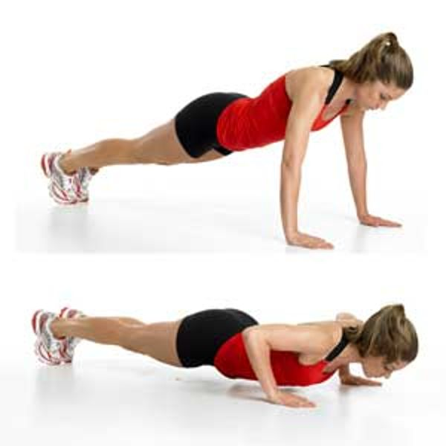](http://www.google.co.uk/url?sa=i&rct=j&q=&esrc=s&source=images&cd=&cad=rja&uact=8&ved=0ahUKEwih2Njjme7VAhVCVhQKHQtoD2sQjRwIBw&url=http://northphoenixfamily.com/5-realistic-workouts-busy-stay-home-parent/&psig=AFQjCNEKIUohcByJHAPfrvuSRcCtL_WQ0w&ust=1503606737944232)Examples**

**[](http://www.google.co.uk/url?sa=i&rct=j&q=&esrc=s&source=images&cd=&cad=rja&uact=8&ved=0ahUKEwih2Njjme7VAhVCVhQKHQtoD2sQjRwIBw&url=http://northphoenixfamily.com/5-realistic-workouts-busy-stay-home-parent/&psig=AFQjCNEKIUohcByJHAPfrvuSRcCtL_WQ0w&ust=1503606737944232)**

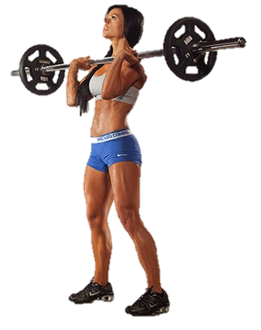

**Holding the press-up position**

Triceps are contracting isometrically

**Downward phase of the press-up**

Triceps are contracting eccentrically

**Upward phase of the press-up**

Triceps are contracting concentrically

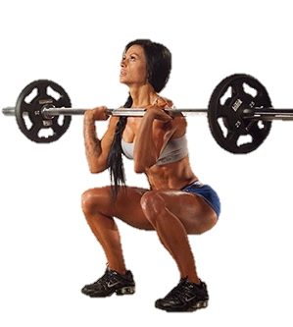

**Holding the Squat** position

Quadriceps are contracting isometrically

**Upward phase of the Squat**

Quadriceps are contracting concentrically

**Downward phase of the Squat**

Quadriceps are contracting eccentrically

**B5 Fibre types**

**Key Words**

**Mitochondria:** Found in the muscle and is the part of the cell where aerobic respiration takes place.

**Aerobic Respiration:** Producing energy using oxygen, energy is released from glucose. (Aerobic activities are generally low intensity and endurance).

**Anaerobic Respiration:** Producing energy without oxygen, energy is released from glucose. (Anaerobic activities involve high intensity and power).

|  |  |  |
| --- | --- | --- |
| **Type** | **Characteristics** | **Sporting Examples** |
| Type I  Slow Twitch | * Contract Slowly * Low force of contraction * Aerobic * High resistance to fatigue | Endurance events:  Marathon  Triathlon  Long distance rowing |
| Type IIa  Fast Twitch | * Contract fast * Medium force of contraction * Aerobic & Anaerobic * Medium resistance to fatigue | Middle distance events:  400m  Tennis Rally  Combination punches  Gymnastics floor routine |
| Type IIx  Fast Twitch | * Contract very fast * High force of contraction * Anaerobic * Low resistance to fatigue | Power events:  100m  Shot-put  Javelin  Power lifting |

[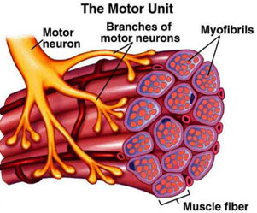](https://www.google.co.uk/url?sa=i&rct=j&q=&esrc=s&source=images&cd=&cad=rja&uact=8&ved=0ahUKEwiZ0bOI3fjPAhVJnBoKHdzsADUQjRwIBw&url=https://www.t-nation.com/training/secret-to-motor-unit-recruitment&bvm=bv.136593572,bs.1,d.ZGg&psig=AFQjCNG5h3aPHQ5HmzrWXRnokgRY4cW_IA&ust=1477580104429784)

**All or none law**

The muscular system works with the nervous system to bring about muscle contraction.

Impulses are sent to the **motor neurones.** (nerves) The motor neuron is attached to a number of muscle fibres in the muscle. Together these are call a **motor unit.** The muscle fibres within the motor unit will be of the same type. When the motor neuron receives a signal to contract, all the fibres attached to the motor neurone will contract. This is called the all or none law.

The force the muscle produces will depend on the amount of motor units stimulated to contract

**B6 Responses of the muscular system to a single exercise session**

|  |  |
| --- | --- |
| **Response** | **Explanation** |
| [Image result for muscles increase blood supply](https://www.google.co.uk/url?sa=i&rct=j&q=&esrc=s&source=images&cd=&cad=rja&uact=8&ved=0ahUKEwjdhrKB6_jPAhWCuhoKHUHCBx0QjRwIBw&url=https://thesportsphysio.wordpress.com/2015/03/11/squeezing-some-facts-out-of-blood-flow-restriction-training-a-guest-blog-by-paul-head/&bvm=bv.136811127,bs.2,d.ZGg&psig=AFQjCNFKjMbsaRFaWu_rHCYYdDYmcu-5dg&ust=1477583867437671)Increased blood supply | Blood carries oxygen. Oxygen is needed for energy. When we exercise there is an increase in demand for oxygen and glucose in the muscles, which is met by an increase in blood supply. Blood vessels expand or get wider to allow more blood to enter your muscles. This is called v**asodilation**. Blood flow increases significantly to ensure that the working muscles are supplied with the oxygen they need as well as to remove waste products such as carbon dioxide. |
| Increase in muscle temperature | When we produce energy for exercise it creates heat. The more you exercise or the harder you train, the more energy your muscles need. This results in more heat being produced. The amount of heat your muscles produce is in direct relation to the amount of work they perform. This principle is used in a warm-up which prepares your muscles for exercise by slowly increasing their temperature. |
| Increased muscle pliability | The warming of your muscles during activity makes them more pliable and flexible. Pliable muscles are less likely to suffer from injuries such as muscle strains. An increase in pliability will improve joint flexibility as warm and pliable muscles are able to stretch further. |
| [Image result for lactic acid](http://www.google.co.uk/url?sa=i&rct=j&q=&esrc=s&source=images&cd=&cad=rja&uact=8&ved=0ahUKEwjyqJPZ7fjPAhXH1RoKHd9WBtEQjRwIBw&url=http://www.bbc.com/news/health-19194806&bvm=bv.136811127,bs.2,d.ZGg&psig=AFQjCNH5crJ5vFjg42L9P6OBP427RQlG0A&ust=1477584543868752)Lactate accumulation | You may have experienced an uncomfortable burning sensation in your muscles during high intensity exercise. This is most likely caused by the build-up of lactic acid which is a waste product produced during anaerobic exercise. This build-up of acid in the muscle tissue will result in rapid fatigue and will impede muscular contractions if it is not removed quickly |
| [Image result for micro muscle tears](https://www.google.co.uk/url?sa=i&rct=j&q=&esrc=s&source=images&cd=&cad=rja&uact=8&ved=0ahUKEwi-3abf7PjPAhUFiRoKHXZXBQMQjRwIBw&url=https://gymjunkies.com/learn-how-tearing-your-muscles-leads-to-fat-loss/&bvm=bv.136811127,bs.2,d.ZGg&psig=AFQjCNF0GJZr5PmafVCiKxKo2hV2faQ8pg&ust=1477584322521740)Microtears | During resistance training such as weight training, your muscles are put under stress to the point that tiny tears occur in the muscle fibres. These micro tears cause swelling in the muscle tissue which causes pressure on the nerve endings and pain. Training improvements will only be made if the body has rest and time to repair these micro tears, making the muscle a little bit stronger than it was before. |
| [Image result for delayed onset muscle soreness](http://www.google.co.uk/url?sa=i&rct=j&q=&esrc=s&source=images&cd=&ved=0ahUKEwjDh6347fjPAhWFVRoKHSkyDOMQjRwIBw&url=http://truthofbuildingmuscle.com/what-is-delayed-onset-muscle-soreness-doms-for-short&bvm=bv.136811127,bs.2,d.ZGg&psig=AFQjCNGyMEgIaa8OaNhdXZLC1J0yqTnGMA&ust=1477584650018066)Delayed onset of muscle soreness (DOMS) | Delayed onset of muscle soreness (or DOMS) is the pain felt in muscles 24–48 hours (typically) after taking part in strenuous exercise. The soreness usually occurs at least a day after exercise and can last up to 3 days. DOMS is caused by the micro tears that occur when you exercise, particularly if you are unaccustomed to the intensity of exercise. DOMS is often associated with exercises where eccentric muscle contraction has occurred. |

**B7 Adaptations of the muscular system to exercise**

|  |  |
| --- | --- |
| **Response** | **Explanation** |
| **Hypertrophy**  [Image result for hypertrophy](https://www.google.co.uk/url?sa=i&rct=j&q=&esrc=s&source=images&cd=&cad=rja&uact=8&ved=0ahUKEwiq46jw8PjPAhXCMhoKHbrXAz0QjRwIBw&url=https://bretcontreras.com/training-for-maximum-muscle-growth-explained/&bvm=bv.136811127,bs.2,d.ZGg&psig=AFQjCNF8Dw-fKXBUfXcX1vFQKZRktN9uLQ&ust=1477585429496944) | Regular resistance training where the muscles are overloaded will increase muscle size and strength. The increase in muscle size is a result of the muscles fibres becoming larger due to increases in protein in the muscle cells; this is known as hypertrophy. The muscle fibres increase in size over time so that they can contract with greater force. |
| **Increase Tendon Strength**  **[Image result for tendon strength](http://www.google.co.uk/url?sa=i&rct=j&q=&esrc=s&source=images&cd=&cad=rja&uact=8&ved=0ahUKEwip0OyO8fjPAhVL1hoKHfqoAVAQjRwIBw&url=http://running.competitor.com/2014/12/injury-prevention/new-exercises-fixing-achilles-injuries_119928&bvm=bv.136811127,bs.2,d.ZGg&psig=AFQjCNEPT9dKw5oZ7sBq4VBmPN8vmlhWjA&ust=1477585506289054)** | Tendons are tough bands of fibrous connective tissue designed to withstand tension. Like muscles, tendons adapt to the overloading of regular exercise. Ligaments and tendons, the connective tissue structures around joints, will increase in flexibility and strength with regular exercise. |
| **Increase in Mitochondria**  [Image result for increase mitochondria](http://www.google.co.uk/url?sa=i&rct=j&q=&esrc=s&source=images&cd=&cad=rja&uact=8&ved=0ahUKEwj0t9Wy8fjPAhUHvRoKHUI4BlEQjRwIBw&url=http://www.brinkzone.com/articles/exercise-mimetics-mitochondrial-boosters/&bvm=bv.136811127,bs.2,d.ZGg&psig=AFQjCNF6qGxwwLW1ELnELHeG_ZwTXoT0NQ&ust=1477585566983125) | Within these muscle fibres are tiny structures called mitochondria which are responsible for aerobic energy production. Because of the increase in fibre size, there is room for more and larger mitochondria, which results in the muscles being able to produce more aerobic energy which will improve aerobic performance. |
| [Image result for myoglobin muscle](https://myloview.cz/fototapety/tema/aminokyselina/8/)**Increase in Myoglobin** | Myoglobin is a type of haemoglobin. It is found exclusively in muscles. You can increase the amount of myoglobin stored in your muscles. This is important as myoglobin will transport oxygen to the mitochondria which in turn will release energy. The more myoglobin you have, the more energy will be available for the muscle. |
| **Increase in Glycogen Storage**  [Image result for glycogen](http://www.google.co.uk/url?sa=i&rct=j&q=&esrc=s&source=images&cd=&cad=rja&uact=8&ved=0ahUKEwjkutix8vjPAhUGDxoKHR34CPkQjRwIBw&url=http://www.questionstudy.com/biology/define-glycogen-structure-abd-functions.html&bvm=bv.136811127,bs.2,d.ZGg&psig=AFQjCNGBpMHlx1r4PFYfGWZsuZ4isNaPWQ&ust=1477585820179841) | As your body adapts to long-term exercise, your muscles are able to store more glycogen. This means that you will be able to train at higher intensities for longer as muscle glycogen does not require oxygen to produce energy. ATP & Pc stores also increase. |
| **Improved use of energy sources** | Well-trained athletes are able to use these fats more efficiently, breaking them down into fatty acids and into energy using oxygen. This enables them to use fats as an energy source when carbohydrate becomes scarce. Muscles also get better at breaking down glycogen so you can exercise at high intensities for longer |
| [Image result for lactic acid tolerance](http://www.google.co.uk/url?sa=i&rct=j&q=&esrc=s&source=images&cd=&cad=rja&uact=8&ved=0ahUKEwjxv86h8_jPAhXJHxoKHdVRA9AQjRwIBw&url=http://www.bbc.co.uk/news/health-19194806&bvm=bv.136811127,bs.2,d.ZGg&psig=AFQjCNE0hxqXT0i6fn87xsvFpJFK_UpaHw&ust=1477586075236956)**Increase Tolerance to Lactate** | Anaerobic training stimulates the muscles to become better able to tolerate lactic acid, and clear it away more efficiently. This increasing the body’s ability to work harder for longer without fatiguing. The net result is an increase in the body’s maximal oxygen consumption. This is mainly due to the aerobic adaptations which allow you to work aerobically for longer therefore not producing lactic acid. |

**B8 Additional factors affecting the muscular system**

|  |  |
| --- | --- |
| **Age**  [Image result for age muscle sarcopenia](http://www.google.co.uk/url?sa=i&rct=j&q=&esrc=s&source=images&cd=&cad=rja&uact=8&ved=0ahUKEwjlvvOO9_jPAhUE7BQKHdPvAGwQjRwIBw&url=http://myheart.net/articles/sarcopenia-age-related-muscle-loss/&bvm=bv.136811127,bs.2,d.ZGg&psig=AFQjCNHsFyd1YcjSZbhJOz0-KAVp_6fpMA&ust=1477587117794715) | As you get older your muscle mass will decrease. The onset of this muscle mass loss begins around the age of 50 and is referred to as sarcopenia. Muscles become smaller resulting in a decrease in muscle strength and power. |
| **Cramp** | Cramp is the sudden involuntary contraction of your muscle. The sensation of muscle spasm where you have no control of the tightening of the muscle fibres can be painful and can be prompted by exercise. The muscles of the lower leg are particularly susceptible to cramp during exercise. Cramp can last from a few seconds up to 10 minutes. There are a number of factors that can contribute to cramp. The most common one in sport is dehydration which can result in the inadequate supply of blood to the muscles, reducing the supply of oxygen and essential minerals. To prevent cramp, you should ensure that you drink plenty of fluid during exercise and sport, especially if the weather is hot. Stretching can also help to prevent cramp as this will lengthen the muscle fibres and improve muscle flexibility. |

**BTEC – End of Unit Test (Muscluar System)**

5

6