**BTEC Revision**

**Test**

**Muscular System**

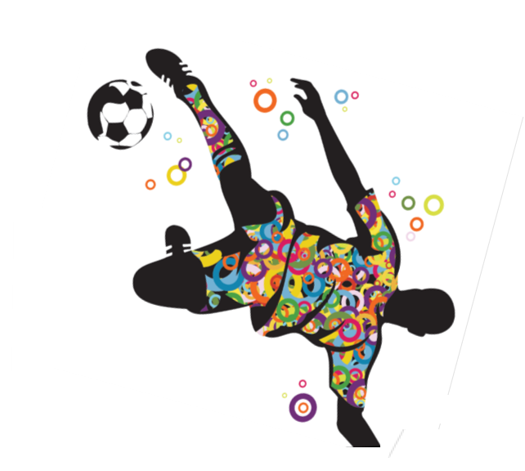

**BTEC – End of Unit Test (Muscluar System)**

5

6

1. Label the Muscles 1-9 in the diagram. (10)

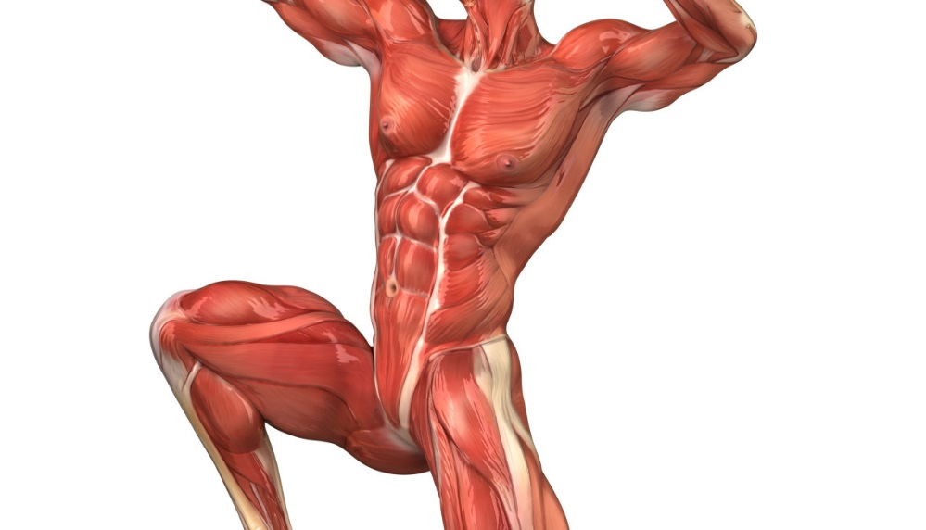1 ____________________________

2 ____________________________

1

3 ____________________________

7

4 ____________________________

2

8

5 ____________________________

3

9

6 ____________________________

7 ____________________________

10

8 ____________________________

4

9 ____________________________

10 ____________________________

1. Name the three types of muscle and give an example of where they can be found in the body? (3)

_________________________________________________________________________________________________________________________________________________________________________________________________________

1. Fill in the table below naming the muscle and its function? (7)

|  |  |
| --- | --- |
| **Muscle** | **Function** |
| **Bicep** |  |
|  | **Flexes the knee** |
| **Gastrocnemius** |  |
|  | **Extends the hip** |
| **Abdominals** |  |
|  | **Lateral flexion of the trunk** |
| **Supinators** |  |

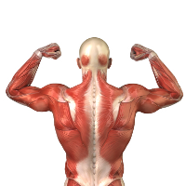

1. Fill in the table below filling in the missing antagonist pair (4)

|  |  |
| --- | --- |
| **Antagonistic Muscle Pairs** | |
| Bicep |  |
| Gastrocnemius |  |
| Hip Flexors |  |
| Hamstring |  |

1. Fill in the missing information below? (6)

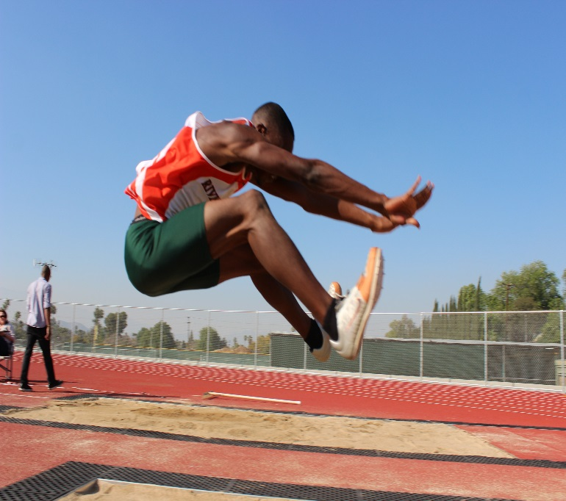

Joint Action:

_____________________

Agonist:

_____________________

Antagonist:

_____________________

Joint Action:

_____________________

Agonist:

_____________________

Antagonist:

_____________________

Joint Action:

_____________________

Agonist:

_____________________

Antagonist:

_____________________

[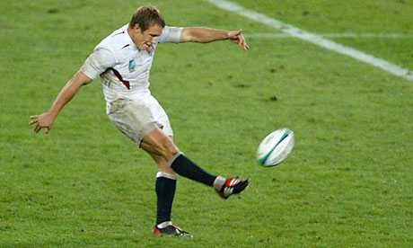](http://www.google.co.uk/url?sa=i&rct=j&q=&esrc=s&source=images&cd=&cad=rja&uact=8&ved=0ahUKEwiy9Yn35M_QAhVFExoKHUQjBQsQjRwIBw&url=http://forum.talkchelsea.net/topic/10997-rugby-world-cup-2011/&psig=AFQjCNFJZqeViuZnhcECGrvHKHK9HaIFxQ&ust=1480571521094747)

1. What muscle is contracting to straighten the knee and kick the ball? (1)

_______________________________

1. 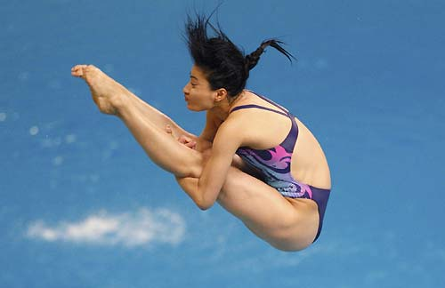Two muscle work together to create flexion of the hip joint. What muscle is the agonist and which is the antagonist? (2)

Agonist = _____________________

Antagonist = __________________

1. 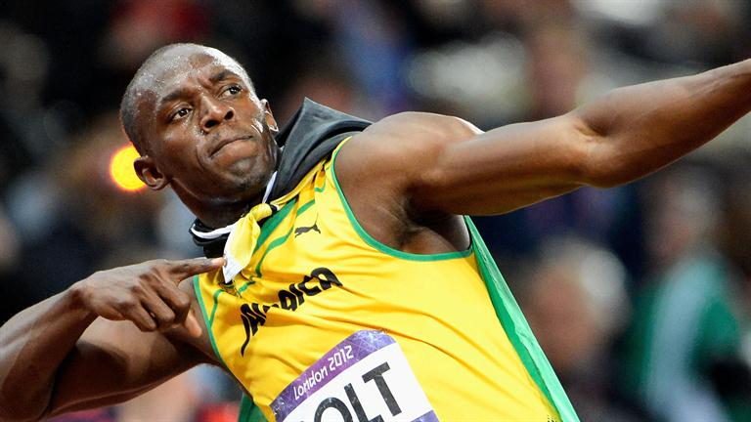Usain bolt is a sprinter, what type of muscle fibres are required for his event. Give three reasons why they are suitable? (3)

___________________________________

___________________________________

___________________________________

___________________________________

1. 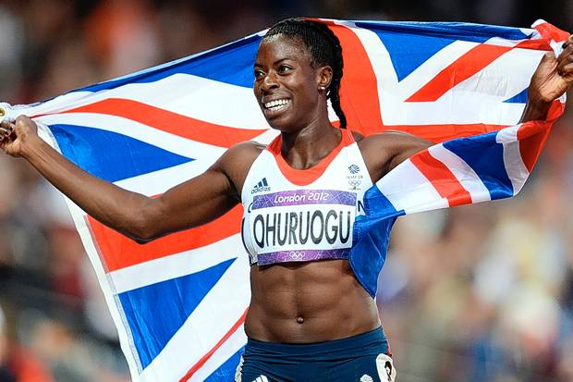Christine Ohuruogu is a 400m runner, what of muscle fibre type is most suitable for this event give three reasons why they are important? (3)

______________________________________

______________________________________

______________________________________

______________________________________

1. Mo Farah is an Olympic gold medallist in the 10,000m. Evaluate the importance of all three muscle fibre types during a 10,000m race? (5)

___________________________________________________________________________________________________________________________________________________________________________________________________________________________________________________________________________________________________________________________________________________________________________________________________________________________________________________________________________________________________________________________________________________________________________________________________________________________________________________________________________________________________________________________________________________________________________________________________________________________________________________________________________________________________________________________________________________________________________________________________________________________________________________________________________________________________________________________________________________________________________________

1. 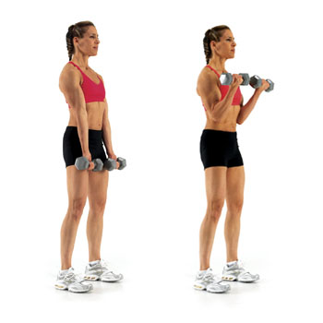Muscles contract in different ways, describe

and explain how the biceps are contracting in

the pictures? (6)

Holding the weight: ___________________________

________________________________________

Downwards phase: ______________________________

________________________________________

Upwards phase: ___________________________

Downwards

phase

Upwards

phase

Holding the weight

________________________________________

1. Describe an isometric muscular contraction and give a sporting situation when you would see one? (3)

______________________________________________________________________________________________________________________________________________________________________________________________________

1. Explain the difference between a synergist and a fixator? (2)

______________________________________________________________________________________________________________________________________________________________________________________________________

1. Warming up is an important aspect of any sports or training session, explain the responses to the muscular system when warming up? (5)

________________________________________________________________________________________________________________________________________________________________________________________________________________________________________________________________________________________________________________________________________________________________________________________________________________________________________________________________________________________________________________________________________________________________________________________________________________________________________________________________________________________________________________________________________________________________________________________________________________________

1. Training over a long period of time will allow your body’s muscular system to change and adapt. Evaluate how your muscular system would adapt to anaerobic exercise such as sprint training? (8)

_______________________________________________________________________________________________________________________________________________________________________________________________________________________________________________________________________________________________________________________________________________________________________________________________________________________________________________________________________________________________________________________________________________________________________________________________________________________________________________________________________________________________________________________________________________________________________________________________________________________________________________________________________________________________________________________________________________________________________________________________________________________________________________________________________________________________________________________________________________________________________________________________________________________________________________________________________________________________________________________________________________________________________________________________________________________________________________________________

1. Explain how age affects the muscular system? (2)

______________________________________________________________________________________________________________________________________

1. 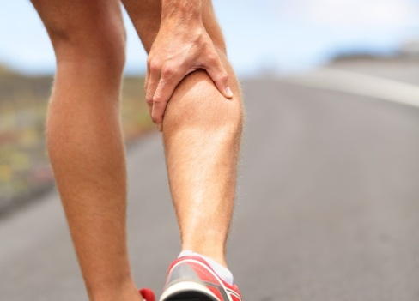John was playing a rugby match and got cramp in his gastrocnemius with 10 minutes to go, explain what cramp is and how it could have been caused? (2)

____________________________________________

____________________________________________

____________________________________________

1. Explain how the musculo-skeletal systems work together to create movement? (8)

___________________________________________________________________________________________________________________________________________________________________________________________________________________________________________________________________________________________________________________________________________________________________________________________________________________________________________________________________________________________________________________________________________________________________________________________________________________________________________________________________________________________________________________________________________________________________________________________________________________________________________________________________________________________________________________________________________________________________________________________________________________________________________________________________________________________________________________________________________________________________________________

**[](http://boydhoffmann.com/)Self-Assessment**

* You are now going to assess your work
* Fill in any incorrect answers in Green pen
* Give yourself a score below

80

**Self-Assessment**

Write a short post it note on your

knowledge of the muscular system.

What are your strengths and what

are your weaknesses?

Post *it*