Aylesford’s Artists on display at Maidstone Museum 11th February to 16th March

Thanks must go to the Art Department, the A Team and all the Aylesford students that entered the “Living with Dementia” Art Competition. Congratulations must go to the 59 students whose work will be on display from 11th February to the 16th March and a particular well done to

George D 1st Prize
Alicia R 2nd Prize
Tiffany S 3rd Prize
Aimee S 4th Prize

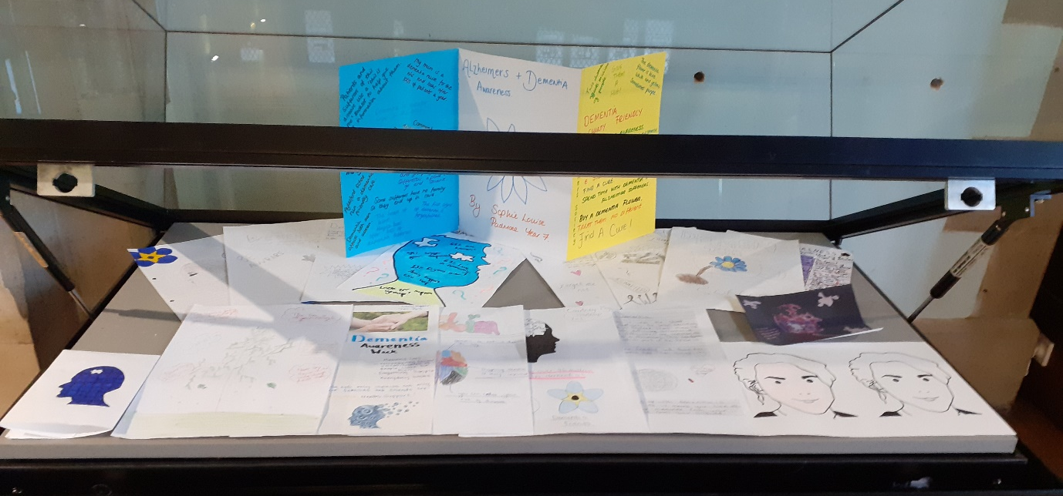

This competition is in combination with the continuing efforts that the school’s A Team is doing to encourage Aylesford students and the local community to be more Dementia Friendly. They have been supported by KCC and the community group Building a Dementia Friendly Maidstone, as well as Ann Franks, from the Garden of England Home Care in Maidstone, who has done a tremendous job of creating the display.

Please see the attached poster for more details regarding the display.

The Museum’s address is St Faith's St, Maidstone ME14 1LH and contact Mr Neeve (Philip.neeve@aylesford.kent.sch.uk) if you have any further queries.

