UNIT 1: FUNDAMENTALS OF IT
TOPIC: 1.7 UNITS OF MEASUREMENT

Converting Denary to Binary Numbers

What is Binary?
Why do computers use binary?

Complete the table below:
No of bits/bytes | Common description of bits/bytes
 | a 1 or a 0 (b)
 | 1 nibble
8 bits
 | 1 Kilobyte (KB)
1024 Kilobytes
 | 1 Gigabyte (GB)
1024 Gigabytes
1024 Terabytes

Level | Outcome | Success Criteria
BRONZE | I know how numbers are stored in Binary | - I can identify that binary is a series of 1 and 0  - I can identify the size of a bit, nibble, byte, kilobyte, megabyte, gigabyte, terabyte, petabyte
SILVER | Converting binary to denary | - I can use the conversion table given to me and convert binary to denary  - I can use the method to convert denary to binary
GOLD | Apply my knowledge to past paper questions | - I can convert 8 bit binary numbers to denary and vice-versa independently  - I can replicate the conversion table  - I can describe why computers use binary


Example | Denary = 3
Answer in binary | 00000011
Calculation for answer | 1 + 2 = 3

128 | 64 | 32 | 16 | 8 | 4 | 2 | 1
0 | 0 | 0 | 0 | 0 | 0 | 1 | 1

Task 1 | Denary = 6
Answer in binary
Calculation for answer | 2 + 4 = 6

128 | 64 | 32 | 16 | 8 | 4 | 2 | 1
0 | 0 | 0 | 0 | 0 | 1 | 1 | 0

Task 2 | Denary = 15
Answer in binary
Calculation for answer

128 | 64 | 32 | 16 | 8 | 4 | 2 | 1

Task 3 | Denary = 21
Answer in binary
Calculation for answer

128 | 64 | 32 | 16 | 8 | 4 | 2 | 1

Task 4 | Denary = 39
Answer in binary
Calculation for answer

128 | 64 | 32 | 16 | 8 | 4 | 2 | 1

Task 5 | Denary = 54
Answer in binary
Calculation for answer

128 | 64 | 32 | 16 | 8 | 4 | 2 | 1

Task 6 | Denary = 78
Answer in binary
Calculation for answer

128 | 64 | 32 | 16 | 8 | 4 | 2 | 1

Task 7 | Denary = 99
Answer in binary
Calculation for answer

128 | 64 | 32 | 16 | 8 | 4 | 2 | 1

Task 8 | Denary = 106
Answer in binary
Calculation for answer

128 | 64 | 32 | 16 | 8 | 4 | 2 | 1

Task 9 | Denary = 180
Answer in binary
Calculation for answer

128 | 64 | 32 | 16 | 8 | 4 | 2 | 1

Task 10 | Denary = 200
Answer in binary
Calculation for answer

128 | 64 | 32 | 16 | 8 | 4 | 2 | 1

Converting Binary to Denary Numbers

Calculating a denary number from a binary number

Example 1: binary number = 00000011
128 | 64 | 32 | 16 | 8 | 4 | 2 | 1
0 | 0 | 0 | 0 | 0 | 0 | 1 | 1
0 | 0 | 0 | 0 | 0 | 0 | 2 | 1
Answer | 2 + 1 = 3

Example 2: binary number = 00001011
128 | 64 | 32 | 16 | 8 | 4 | 2 | 1
0 | 0 | 0 | 0 | 1 | 0 | 1 | 1
0 | 0 | 0 | 0 | 8 | 0 | 2 | 1
Answer | 8 + 2 + 1 = 11

Task 12: binary number = 00001111
128 | 64 | 32 | 16 | 8 | 4 | 2 | 1
0 | 0 | 0 | 0 | 1 | 1 | 1 | 1
Answer

Task 13: binary number = 00101010
128 | 64 | 32 | 16 | 8 | 4 | 2 | 1
0 | 0 | 1 | 0 | 1 | 0 | 1 | 0
Answer

Task 14: binary number = 01011011
128 | 64 | 32 | 16 | 8 | 4 | 2 | 1
0 | 1 | 0 | 1 | 1 | 0 | 1 | 1
Answer

Task 15: binary number = 00101101
128 | 64 | 32 | 16 | 8 | 4 | 2 | 1
Answer

Task 16: binary number = 11001100
128 | 64 | 32 | 16 | 8 | 4 | 2 | 1
Answer

Task 17: binary number = 11100010
128 | 64 | 32 | 16 | 8 | 4 | 2 | 1
Answer

Task 18: binary number = 01101001
128 | 64 | 32 | 16 | 8 | 4 | 2 | 1
Answer

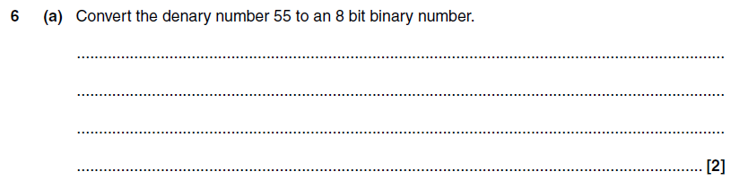
1.
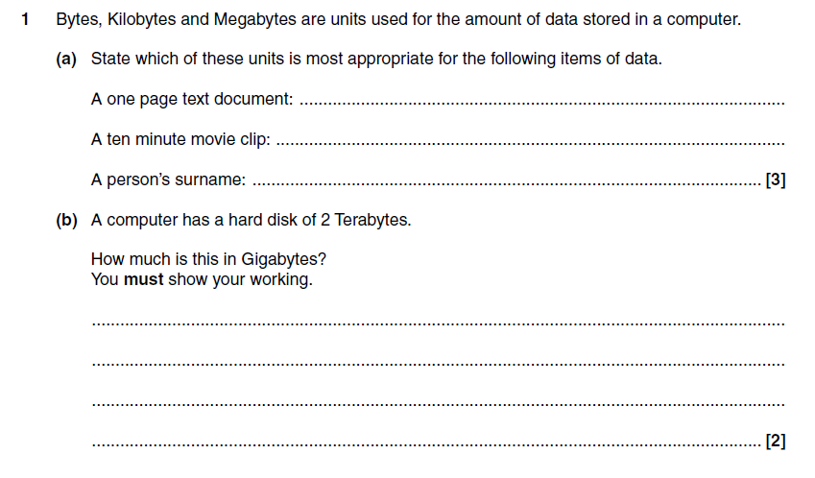
2.

