Name



Class

**1.** For a job of your choice – perhaps one that you would like to do in the future – use the Internet to research what it is like to work in that job. Be sure to find out:

(a) what qualifications or training are needed

(b) what the job outlook is for the future. (Are the numbers of people needed in that job expected to grow or shrink?)

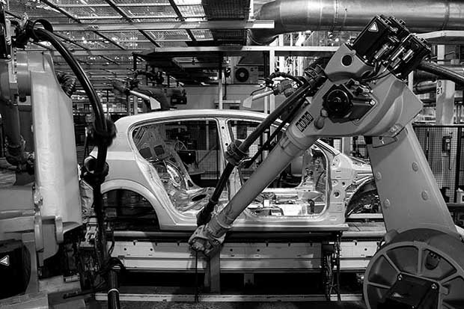

Robots working in a car-manufacturing factory

**2.** Study photo **A**. **Suggest** two advantages and two disadvantages of using robots in modern manufacturing.

*Advantages of robots include*

*Disadvantages of robots include*

**3.** **Give** two ways in which manufacturing has changed in the UK.

1

2

|  |  |  |  |
| --- | --- | --- | --- |
|  | 1800 | 1900 | 2018 |
| Tertiary sector | 10% | 15% | 72% |
| Quaternary sector | 0% | 0% | 12% |

The tertiary and quaternary sectors

**4.** Look at chart **B** on the next page. The partly completed divided bar chart shows changes in the UK’s employment sectors from 1800 to 2018.

(a) **Complete** chart **B** by adding the tertiary and quaternary sectors, as given in table **C** above.

Remember with divided bar charts to always plot in sequence, so add the next group (tertiary) first. For example, in 1800, 75% (primary) and 15% (secondary) add up to 90%. You then add tertiary (10%) to this and colour it according to your key. When you’ve plotted all three charts, make sure that each one adds up to a total of 100%.

Tip!

(b) Add the tertiary and quaternary sectors to the key.

(c) Add the annotations below, in the correct places on the chart.

The secondary sector was much more important in 1900.

There are very few people working in the primary sector.

Most people work in the tertiary sector.

The quaternary sector has appeared.

Mechanisation has reduced the secondary sector.

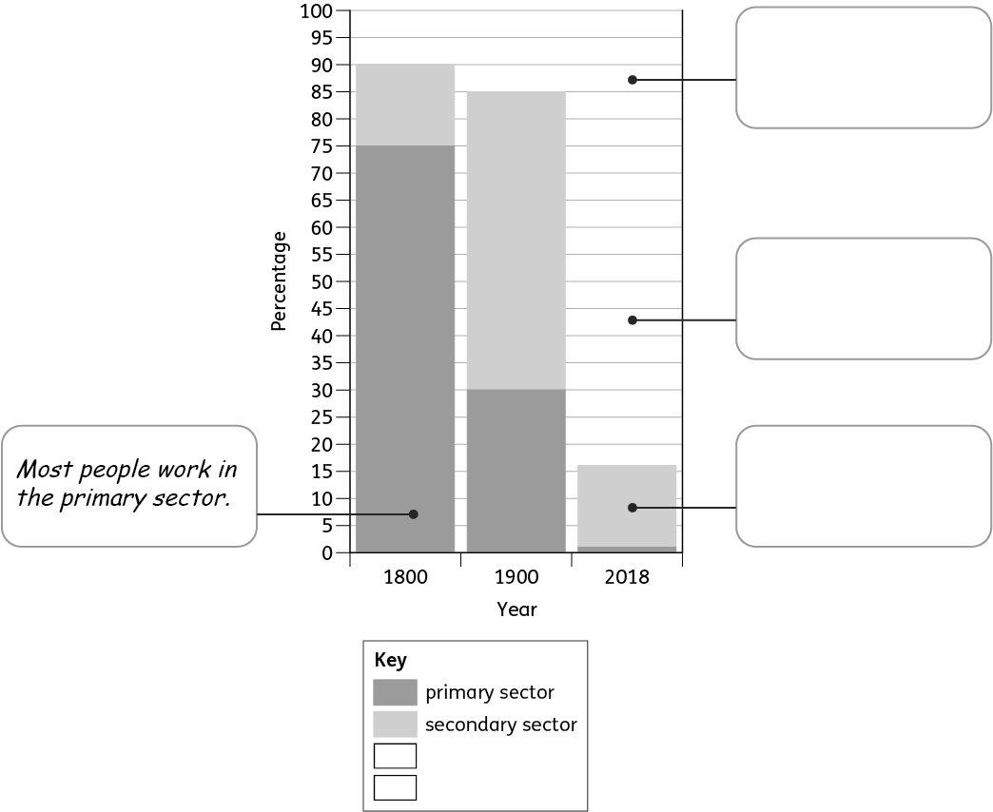

The UK’s changing employment structure