
Name:
Exam Style Questions
Ensure you have: Pencil, pen, ruler, protractor, pair of compasses and eraser

You may use tracing paper if needed

Guidance

- Read each question carefully before you begin answering it.
- Don’t spend too long on one question.
- Attempt every question.
- Check your answers seem right.
- Always show your workings



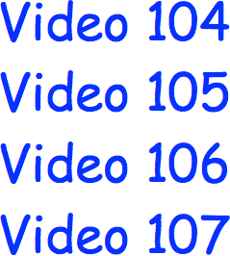
Revision for this topic

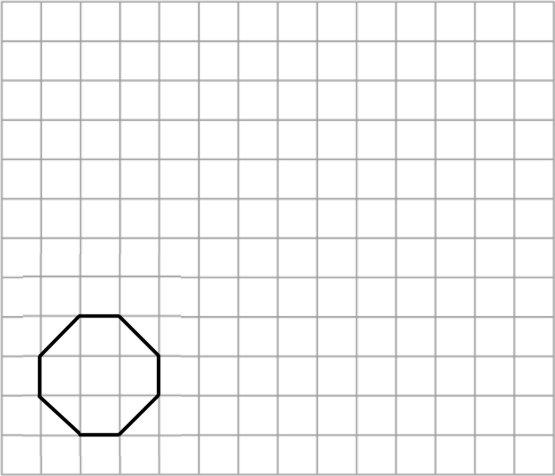

  - Name the shape drawn on the grid.

.........................

(1)

  - On the grid, enlarge the shape using a scale factor of 2

(2)

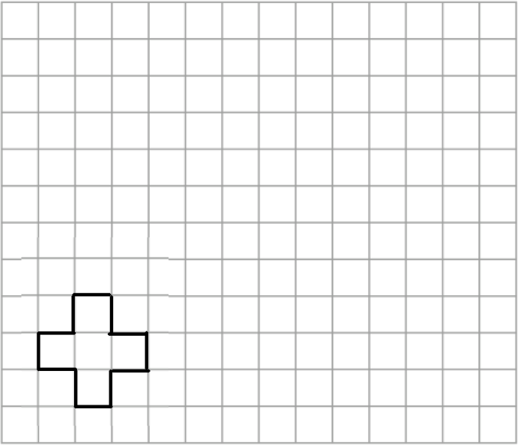

On the grid, enlarge the shape using a scale factor of 3.

(2)

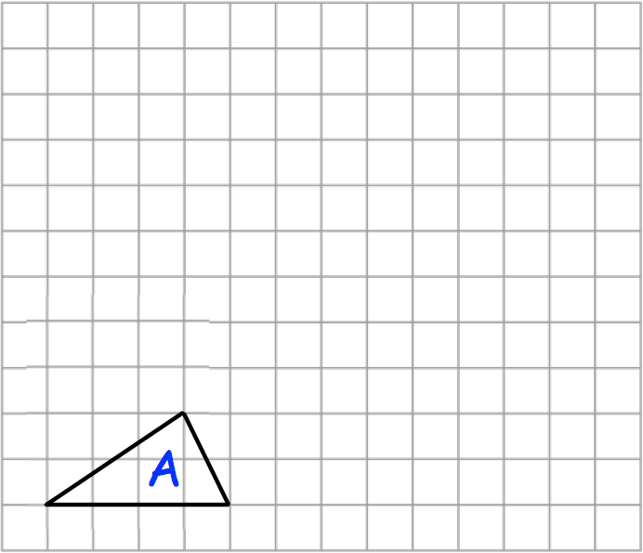

On the grid, draw an enlargement of shape A with a scale factor of 2.

(2)

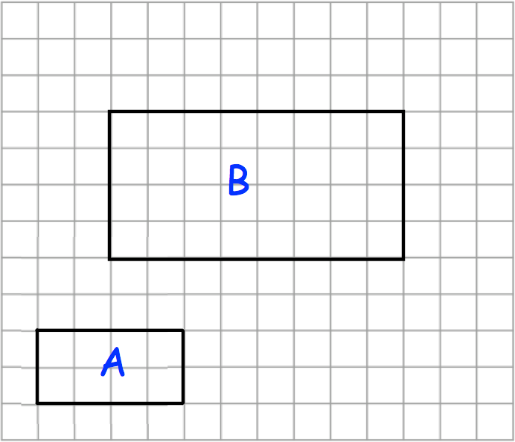

- Work out the area of rectangle A.

.........................cm²

(1)

Rectangle B is an enlargement of rectangle A.

- What is the scale factor of the enlargement?

...........................

(1)
- The diagram shows a triangle.
The dotted line is a side of an enlargement of the triangle.
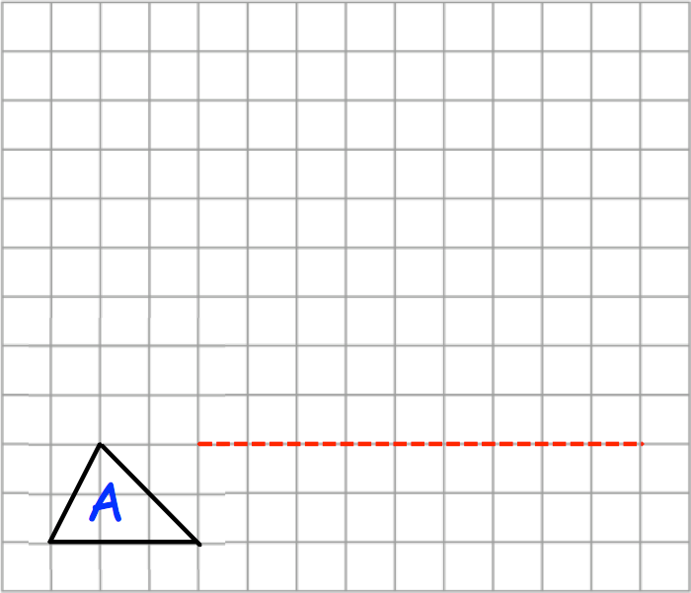

  - What is the scale factor of the enlargement?

...........................

(1)

  - Complete the enlarged triangle.

(2)

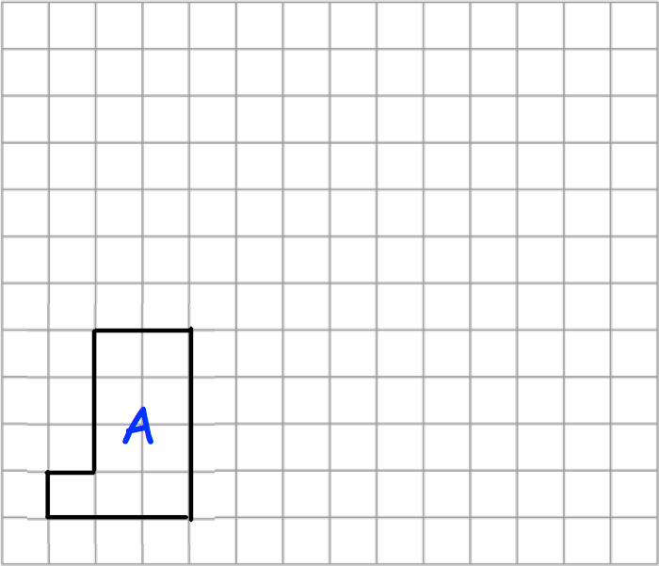

Work out the area of the L-shape after an enlargement of scale factor 2.

.........................cm²

(2)

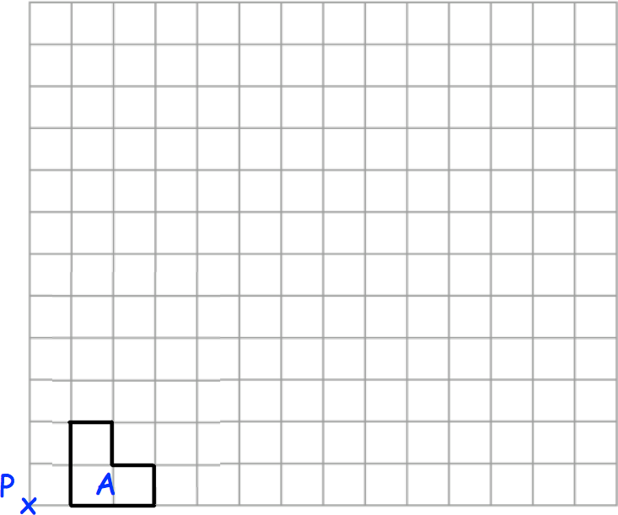

Enlarge shape A by scale factor 4, using the point P as centre of enlargement.

(3)

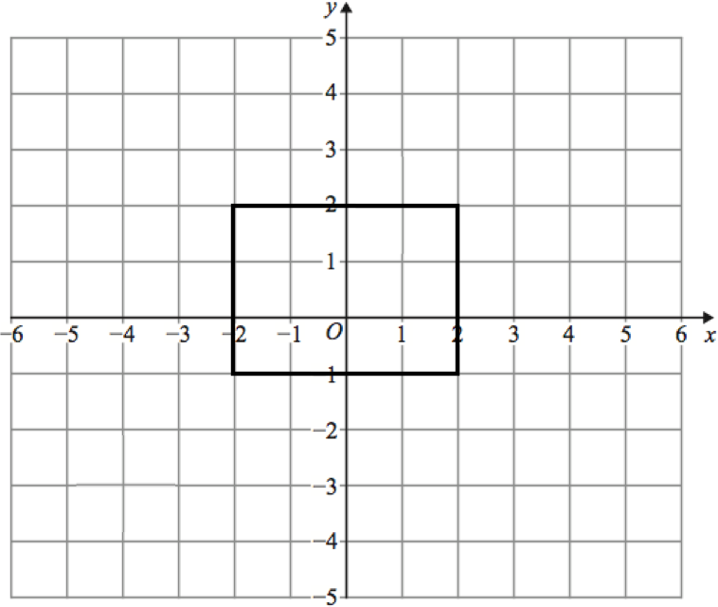

Enlarge the rectangle by scale factor 2, using centre of enlargement (−1, 0).

(3)

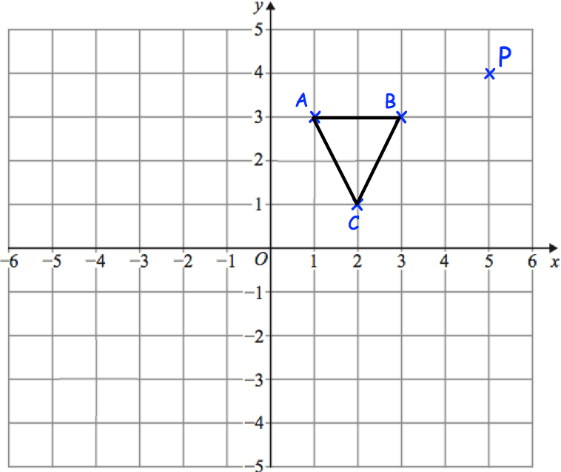

Enlarge triangle ABC by scale factor 2, using the point P as the centre of enlargement.

(3)

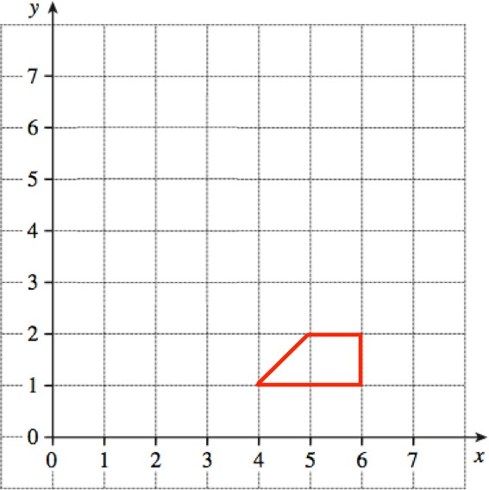

Enlarge the trapezium by scale factor 3, centre (6, 0).

(2)

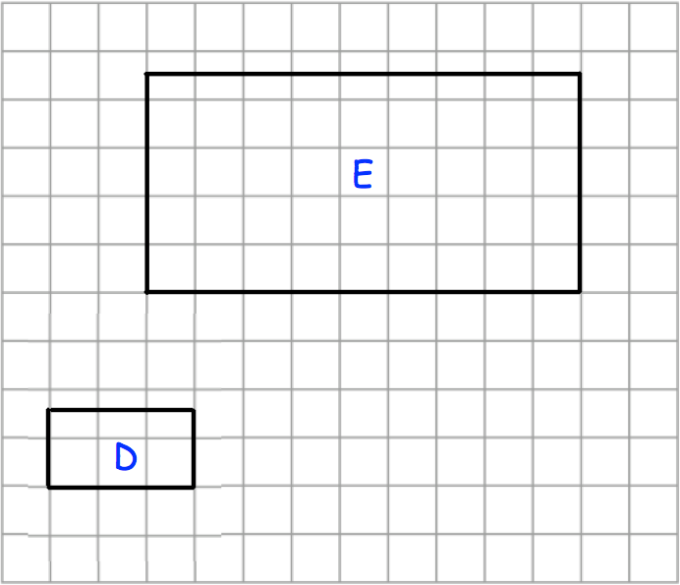

- What is the scale factor of the enlargement?

...........................

(1)

Rectangle E is enlarged by scale factor 20 to give rectangle F.

- Write down the length and width of rectangle F.

Length cm

Width cm

(2)

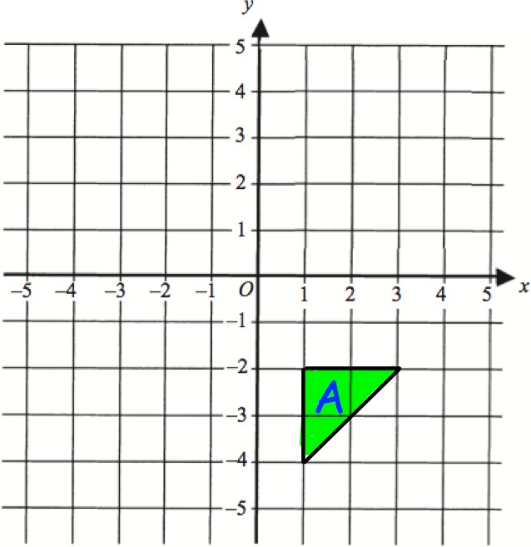

Enlarge triangle A by scale factor 2, using centre of enlargement (5, −5).

(3)

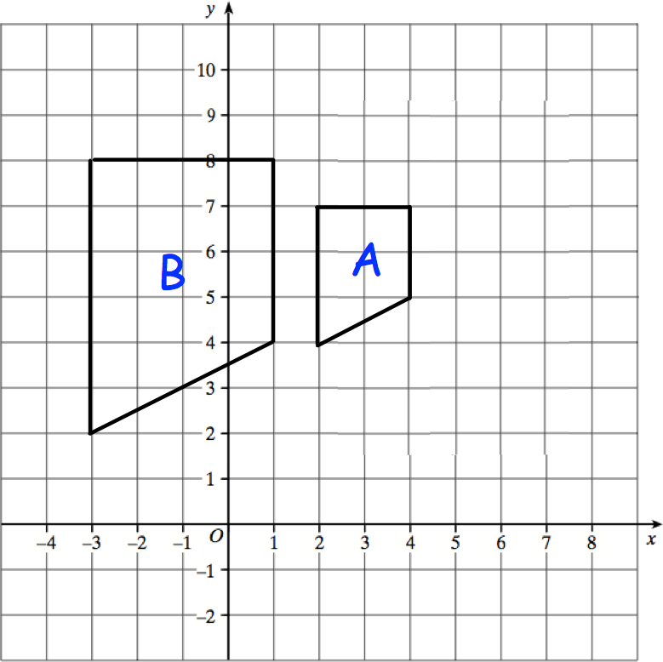

Describe fully the single transformation that maps shape A onto shape B.

.....................................................................................................................................

.....................................................................................................................................

.....................................................................................................................................

.....................................................................................................................................

(2)

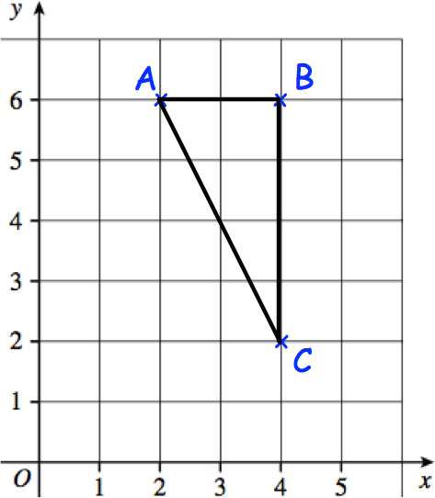

Triangle ABC is drawn on the grid.

Enlarge triangle ABC with scale factor ½ and centre (0,0)

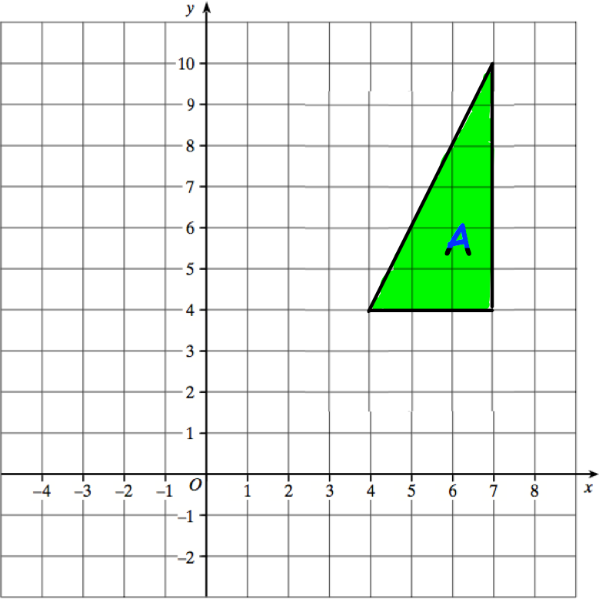

Draw the enlargement of shape A with scale factor ⅓ and centre of enlargement (1,1).

(3)

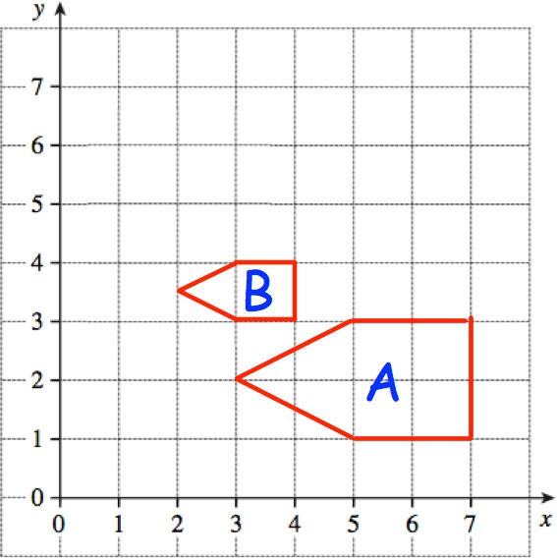

Describe fully the single transformation that maps shape A onto shape B.

.....................................................................................................................................

.....................................................................................................................................

.....................................................................................................................................

.....................................................................................................................................

(2)

